Wind energy Can Mitigate market power

Ori Ben-Moshe, The Unit of Energy Engineering, Faculty of Engineering Sciences, Ben-Gurion University of the Negev, Israel, oribenm@post.bgu.ac.il
Ofir D. Rubin, Department of Public Policy & Administration, Guilford Glazer Faculty of Business & Management, Ben-Gurion University of the Negev, P.O. Box 653, Beer-Sheva, 84105, Israel, +972-8-6472597, orubin@som.bgu.ac.il

Overview
There is a large and growing body of literature suggesting that electricity prices decline in wind energy penetration rate (e.g. Olsina et al. 2007; Botterud et al. 2010; Green & Vasilakos 2010; Traber & Kemfert 2011; Woo, et al. 2011; Rubin & Babcock 2013). Commonly, two intertwined factors explain this phenomenon: public support given to investments in wind power capacity (and other renewables) which enables wind generators to compete, and the fact that once wind capacity is installed, marginal generation cost is negligible compare with conventional units. Still, it is unclear whether these observations are generalizable and if not, what are the conditions of which wind energy has no dampening effect on electricity market prices.

Methods
In this study, we extend the model by Twomey & Neuhoff (2010) to examine whether an increase in wind energy penetration rate necessarily brings market prices down. The original model investigates the linkage between wind energy and market prices in a monopoly, duopoly and competitive market regimes. In this model, the ownership of wind power capacity is introduced to the market by price-taker firms. We expand this framework in two ways. First, we advance the model for the case of oligopoly market, which in many cases may be more realistic. Second, we allow a degree of freedom in the ownership type of wind power capacity. That is, in our model the strategic conventional generators firms (GF) are not prevented from owning and operating wind farms. The extended model allows us to generalize outcomes in regard the integration of wind energy into deregulated electricity markets and their impact on electricity prices. We examine analytically and numerically how the industry structure of the electricity sector (i.e. firms' number and ownership type) affects the ability to exercise market power and what are the implications for electricity prices and the distribution of welfare in this market.

Results
Our main results are: first, in relatively more concentrated markets, conventional GFs, which also own wind energy farms, can raise their revenues from these farms although they cannot control their output. This is because they are able to manipulate market prices while maximizing joint profits from their conventional and renewable generators.
Second, we show that the impact of wind energy penetration rate on market prices is not evident; it depends on wind energy ownership type. In particular, for low level of wind energy diversification (i.e. conventional GFs own most wind capacity), prices may actually raise with wind energy penetration rate. In Figure 1 we depict simulation results for the average market price against these two factors. Under certain set of assumptions, the impact of integrating more wind energy on market prices is not always clear. More precisely, in this particular example, ownership of up to 60% of wind power capacity by conventional GF’s lowers market prices while in the opposite case, the market price may actually increase.
Third, we find that the ratio of average price received by wind energy producers to the average market price reveals a picture that does not benefit the former. Not just that average prices for wind energy are consistently lower, but also the benefits for wind energy relies on the ability of strategic conventional GFs to manipulate prices as wind energy producers revenues depend on it.

Conclusions
Our theoretical framework facilitates greater flexibility in modelling the electric industry structure with respect to firm number and ownership type of wind power capacity (in terms of firm behaviour). The analytical results, followed by numerical example, indicate that it is not always that wind energy brings electricity prices down. Our study portrays the conditions for which prices are likely to increase. Actually, the decrease observed in the cited articles above are cases in which wind energy had the ability to mitigate market power. This occurs when the number of firms is large enough, the ownership of wind energy is sufficiently diversified or often a combination of the two. Importantly, our study defines the circumstances in which the question who invests in wind power capacity may determine market prices and welfare distribution.
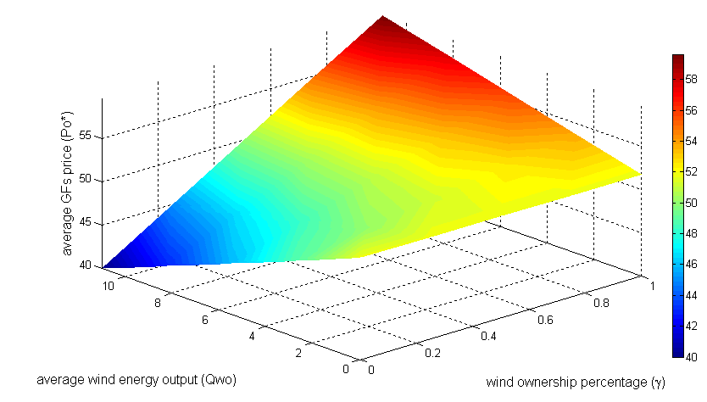

Figure 1: Average market price as a function of average wind energy output and wind ownership percentage by conventional GFs.

References
Botterud, A., Wang, J., Miranda, V., & Bessa, R. J. (2010). Wind power forecasting in US electricity markets. The Electricity Journal, 23(3), 71-82.
Green, R. & Vasilakos, N., (2010). Market behaviour with large amounts of intermittent generation. Energy Policy, pp. Volume 38, Issue 7, Pages 3211–3220.
Olsina, F., Ro¨scher, M., Larisson, C. & Garce´s, F., (2007). Short-term optimal wind power generation capacity in liberalized electricity markets. Energy Policy, pp. 35 (2), 1257–1273.
Rubin, O. D., & Babcock, B. A. (2013). The impact of expansion of wind power capacity and pricing methods on the efficiency of deregulated electricity markets. Energy, 59, 676-688.
Traber, T. & Kemfert, C., (2011). Gone with the Wind? - Electricity Market Prices and Incentives to Invest in Thermal Power Plants under Increasing Wind Energy Supply. Energy Economics, pp. 33 (2): 249-256.
Twomey, P. & Neuhoff, K., (2010). Wind power and market power in competitive markets. Energy Policy, p. 38: 3198–3210.
Woo, C., Horowitz, I., Moore, J. & Pacheco, A., (2011). The impact of wind generation on the electricity spot-market price level and variance: The Texas experience. Energy Policy, pp. 39 (7), 3939–3944.

Acknowledgement
This research was supported by a Grant from the GIF, the German-Israeli Foundation for Scientific Research and Development.

