An Evaluation of US Macroeconomic and Petroleum Market outcomes under Future Economic Scenarios

Gbadebo Oladosu, Oak Ridge National Laboratory, (865) 576-2485, oladosuga@ornl.gov
Paul Newsome Leiby, Oak Ridge National Laboratory, (865) 574-7720, leibypn@ornl.gov
Jennifer C. Li, U.S. Department of Energy, (202) 287-6088, Jennifer.li@hq.doe.gov

Overview

Sluggish economic growth since the “Great Recession” of 2008/2009 and uncertainties about the global economic outlook require policy makers to keep a keen eye on multiple indicators of economic performance. The petroleum market plays an important role in the United States (US) and global economy, and is likely to be an important determinant of future economic conditions. In turn, changes in economic activity resulting from shifting global events and policies may also have strong implications for the petroleum market. Petroleum accounts for about 36% of total primary energy consumption in the United States (US), providing 92%, 38% and 17% of transportation, industrial, and residential and commercial energy use, respectively (EIA, 2017). A recent analysis of data for 2015 by pwC (2017) found that total employment contributions to the US economy by the oil and gas industry, accounting for both operational and investment impacts, is about 10.3 million or 5.6% of US employment. These estimates include impacts of the oil and gas industry on suppliers of its operational and investment requirements, but not those of sectors that purchase oil and gas. The same analysis found that the corresponding total value-added contribution of the oil and gas industry is about $1.3 trillion or about 8% of US GDP. Thus, there are important two-way linkages between the US economy and petroleum markets which implies that shocks to one could have significant implications for the other. This study evaluates the implications of future global economic scenarios for U.S. macroeconomic outcomes, with attention to the petroleum market.

Methods

The analyses employ the Oxford Economic model (OxfEM), a quarterly global macro-econometric model for policy analysis that has been developed over a period of 30 years (Oxford Economics, 2016). The model includes more than 80 countries and trading blocs. Along with other commodities, it models supply, demand and trade for crude oil and refined products. Linkages among countries occur through trade, indicators of competitiveness, interest rate, exchange rate, commodity prices and the world price of manufactured goods. The model is updated monthly and includes three versions with 5-, 10- and 25-year baseline projections. The 10-year, January 2017 version of the model is used in this study.

We simulate a Baseline scenario, six scenarios that are partly or fully based on recent pre-defined scenarios from Oxford Economics, and two additional “global recession” scenarios compiled by the authors, all covering the period out to 2021. The Baseline scenario incorporates current economic conditions and political developments, such as the Brexit vote in July, 2016. The remaining scenarios consider alternative future developments, including potential shifts in U.S. trade policy, implementation of a U.S. stimulus package particularly a tax cuts, tighter policies in China to rein in unsustainable debt growth, stagnation in global demand, and new global fiscal policy measures to boost growth. The trade policy shift scenarios involve tariffs and counter-tariffs between the US and several trading partners. The original tariff simulations by Oxford Economics involved a two-step process. In the first step impacts of the tariffs on trade levels and prices were obtained from simulations with a computable general equilibrium (CGE) model. The impacts on trade levels and prices were then used in OxfEM to simulate these scenarios. In addition, changes in non-labor costs from the CGE simulations were imposed in OxfEM to capture changes in industry input costs that are not reflected in the trade variables.

Results

Results on the impacts of these scenarios on the overall economy, trade, petroleum markets and financial markets are discussed. These results suggest that one of the alternative scenarios, the global fiscal policy boost scenario, produces quarterly real US GDP growths that are consistently above Baseline rates. One scenario is also found that could lead to significant negative U.S. economic growth This scenario combines global economic stagnation with large tit-for-tat tariffs between the U.S. and Mexico/China, new immigration policies, and tax cuts. However, results for the scenario with only the large tit-for-tat tariffs also produced low economic growth, suggesting that these tariffs drive the recession result for the above scenario. The Baseline results suggest that oil prices remain close to $50/bbl into 2017 and 2018, and rise gradually to about $75/bbl by 2021. Global oil prices drop by up to $10/bbl under the alternative scenarios relative to the Baseline before 2019, but drop by as much as $20/bbl by 2021, except in the global fiscal policy boost scenario. In the latter scenario, global oil prices increase by up to $10/bbl by 2020. US crude oil demand increases by up to 2% in two scenarios due to lower global oil prices, but there are small reductions in most of the remaining scenarios. US oil production is not significantly affected, with changes in the range of -0.4% to +0.14% by 2021. As shown in Figure 1, U.S. demand for refined petroleum products increases by less than 0.5% in four scenarios and by more than 1% in three scenarios, relative to the Baseline, by 2021. Only the trade policy scenario with large tit-for-tat tariffs show a significant decrease in refined oil demand of about 1% by 2019.

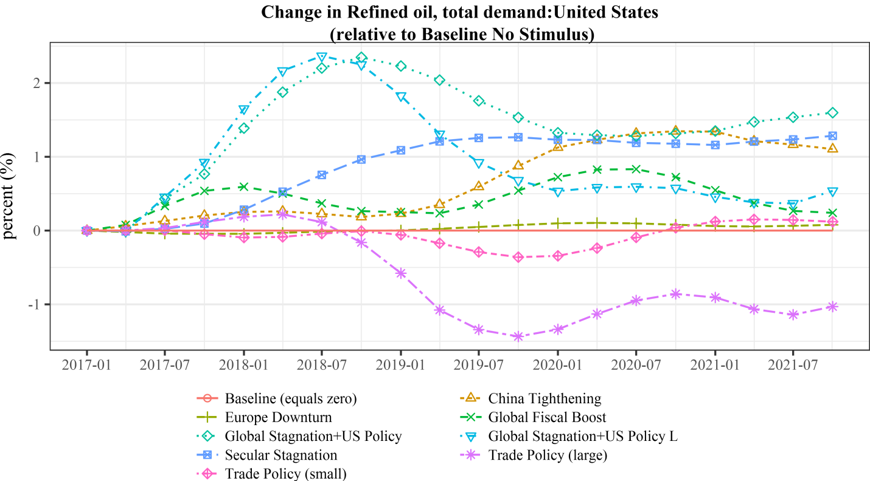

Conclusions

Using a global macro-econometric model, this study provides insights into potential economic and petroleum market outcomes for the US under several future global economic scenarios. The scenarios examined include continued stagnation of the global economy, a global fiscal boost to growth, US policies on stimulus spending, trade and immigration, tighter economic policies in China and the UK’s Brexit vote. These scenarios are found to produce economic outcomes for the US that could be significantly different from the Baseline. The global fiscal policy boost scenario consistently produces higher US economic growth rates than the Baseline over the study period. However, scenarios that involve large tit-for-tat tariffs, despite short-term gains, produce recessionary pressures. We found that impacts on US petroleum supply and demand are in the range of -1.5% to +2.5%, relative to the Baseline, with larger impacts on demand than supply. Changes on global oil prices are substantial, in the range of -$20/bbl to +$10/bbl across all scenarios relative to Baseline prices that rise gradually from about $50/bbl after 2018 to about $75/bbl by 2021.

References
- Oxford Economics (2016) Oxford Global Economic Model: User’s Guide http://www.oxfordeconomics.com/Media/Default/Thought%20Leadership/free-files/oe_user_guide.pdf
- EIA - United States Energy Information Administration (2017) U.S. Energy Facts Explained. https://www.eia.gov/energyexplained/?page=us_energy_home
- pwC (2017) Impacts of the Oil and Natural Gas Industry on the US Economy in 2015 Prepared for American Petroleum Institute. http://www.api.org/~/media/Files/Policy/Jobs/Oil-and-Gas-2015-Economic-Impacts-Final-Cover-07-17-2017.pdf

