Overview

ASSESSMENT OF SOUTH KOREA’S LNG PORTFOLIO CONSIDERING PANAMA CANAL EXPANSION
Juhan Kim, Hanyang University, Phone +82 2 2220 4469, E-mail: juhankim@hanyang.ac.kr
Taeyoung Jin, Hanyang University, Phone +82 2 2220 4479, E-mail: tyjin@hanyang.ac.kr
Jinsoo Kim, Hanyang University, Phone + 82 2 2220 2241, E-mail: jinsookim@hanyang.ac.kr

Panama Canal expansion can have significant impacts on South Korea. An increasing growth of unconventional gas production in the US has gradually turned it into a potential gas exporter. In near future, increasing LNG exports from the US coupled with the capacity of the Panama Canal will change the LNG market(Moryadee et al.,2014). Panama Canal expansion is the key to the change because the route via this canal reduces the voyage by 7500 nautical miles to South Korea from the east coast of the US. Expansion of Panama Canal will allow for reducing the cost of shipping between South Korea and U.S East. South Korea is the second largest importer of LNG in the world. In 2015, LNG imports in South Korea are amounted to 11,889 mcm(IEA,2016). However, South Korea can’t import natural gas in any form other than LNG because of the division of South and North Korea. Further, the high proportion of natural gas in energy mix makes this resource crucial for energy security in Korea. Due to this situation, we review the natural gas optimal portfolio by considering the uniqueness of the Korean Natural gas market and expansion of Panama Canal. In order to assess South Korea’s natural gas optimal portfolio, Juhan kim and Jinsoo Kim(2015) developed complex portfolio model. In South Korea, demand for natural gas differs markedly between winter and summer. Spot trading is used in winter to cope with natural gas shortages. Accordingly, to consider the use of spot contracts in this way, we composes and presents a complex two-step model: the first step consists of the portfolio model represented by the mean-variance model and linear programming model are applied in the second step. Finally, this study evaluates the LNG portfolio results obtained from these models by using energy security index. Using this model, we derived the optimal natural gas portfolio considering the expansion of Panama Canal. Based on these results, we assess the portfolio for natural gas import to Korea from the perspective of energy security and present some relevant policy proposals.

Methods
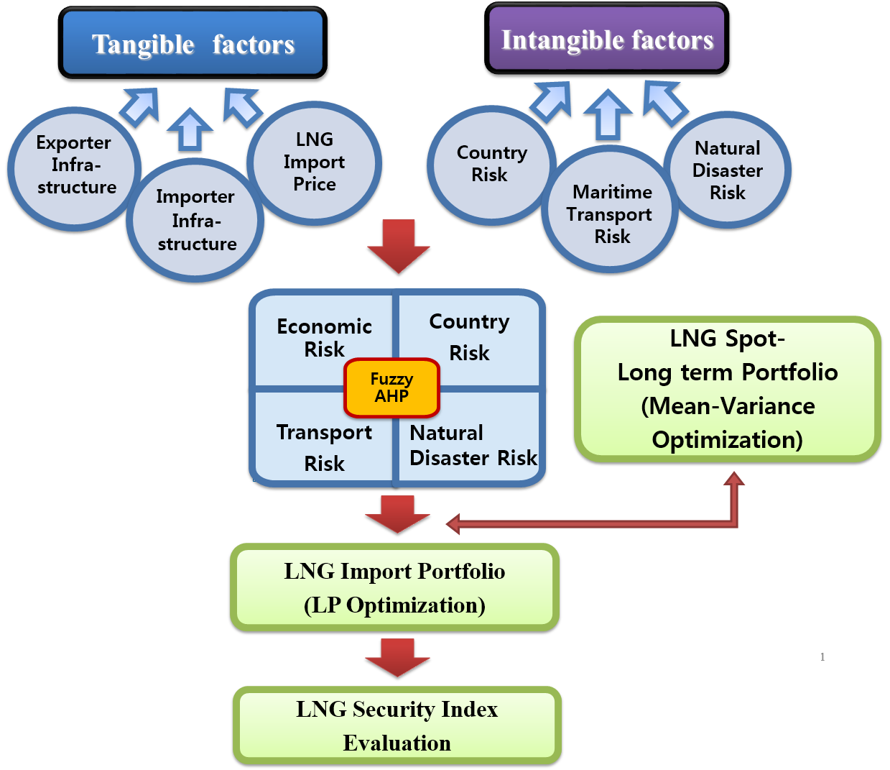
Figure 1. The framework of this study

Figure 1 shows the framework of this study. The model comprises two steps portfolio. First, the study examines the price level and the correlation between long-term and spot contracts to obtain the optimal purchase ratio by using the mean variance portfolio model. The purchase ratio follows the efficient frontier of the cost/risk level related to this price level and degree of correlation. Second, by applying the obtained long-term contract purchase ratio as the constraint equation in the linear programming portfolio model, we determine the LNG import portfolio that minimizes total tangible and intangible costs. In order to account for the natural gas value chain, our model includes both intangible weight factors such as national risks, natural disaster risks, and transportation risks and tangible weight factors such as supply capabilities and import prices. Our model applies a Fuzzy AHP(Analytic Hierarchy Process) to calculate weights. Applying Fuzzy AHP enables this research to reflect the tangible and intangible costs more accurately by using weights based on importance instead of applying the same weight to all costs.

Results
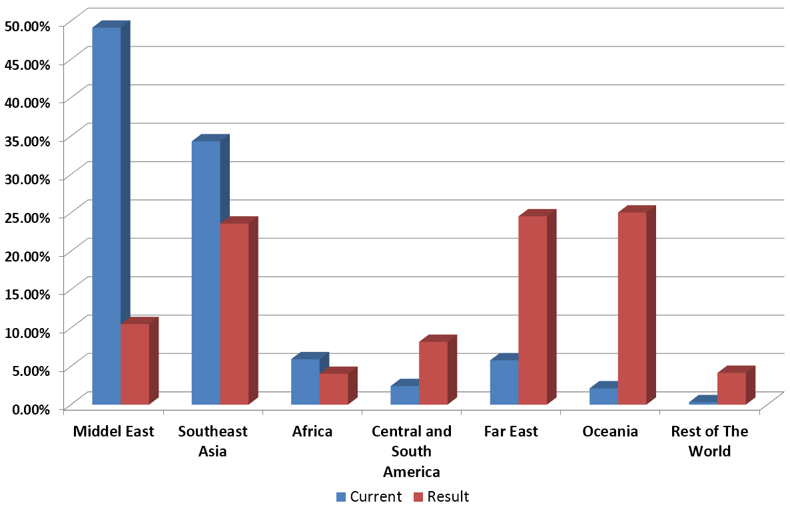
Figure 2. Comparison for current and analysed results of each continental region

First, the optimal ratio between long-term and spot contracts was 80.5% and 19.5% with respect to the cost/risk level. We obtained the economic risks, national risks, maritime transportation risks, and natural disaster risks by analyzing the tangible and intangible factors using the AHP survey results. Then, by applying the AHP results and optimal purchase ratio, we deduced continental region-level and the country-level LNG portfolios. The analytical results of this study show that the supply ratio in the Middle East and in Southeast Asia decreased, while that in the Far East and Oceania greatly increased, as shown in Figure 2. Moreover, the natural gas security index of Korea measured by using actual data on Korea for 2015 was 3.76 at the continental region scale. On the contrary, the adjusted natural gas security index of Korea, measured by using the supply ratios adjusted by the new portfolio, was 1.85, indicating that Korea’s natural gas security index greatly improved compared with the security index based on actual supply.

Conclusions
In this study, given the nature of the value chain in the LNG industry, we constructed and assessed an LNG supply portfolio model considering tangible and intangible costs in order to improve supply stability considering Panama Canal expansion. We developed a complex portfolio model that reflects the price level, correlation between long-term and spot contracts, and tangible and intangible costs based on the LNG value chain. The optimal LNG portfolio calculated in this study has significant policy implications. However, because long-term contracts dominate the natural gas market in Korea, it is not possible to control the LNG import portfolio in the short run. Nevertheless, the findings of this study can be applied to formulate LNG supply policy in the long run, which would significantly improve security policies and reduce the tangible and intangible costs incurred.

References
International Energy Agency (IEA). 2016, “Natural Gas Information,” IEA, Paris.
Juhan Kim and Jinsoo Kim. "Assessment of Koreas LNG Import Portfolio Using Complex Portfolio Model." Energy Security, Technology and Sustainability Challenges Across the Globe, 38th IAEE International Conference, May 25-27, 2015. International Association for Energy Economics, 2015.
Moryadee, Seksun, Steven A. Gabriel, and François Rehulka. "The influence of the Panama Canal on global gas trade." Journal of Natural Gas Science and Engineering 20 (2014): 161-174.

Acknowledgement
This work was supported by the Energy Efficiency & Resources Core Technology Program(No. 20152510101880) of the Korea Institute of Energy Technology Evaluation and Planning (KETEP) granted financial resource from the Ministry of Trade, Industry & Energy, Republic of Korea and by the National Research Foundation of Korea Grant funded by the Korean Government (NRF-205S1A3A2046684).

