Overview

CARBON-NEUTRAL ETHANOL PRODUCTION FROM AN ACRE OF CORN

Nathan Kauffman, Iowa State University, Department of Economics, 515-294-2469, nathank@iastate.edu
Jerome Dumortier, Iowa State University, Department of Economics, 515-294-6173, jrfd@iastate.edu
Dermot Hayes, Iowa State University, Department of Economics, 515-294-6185, dhayes@iastate.edu
Robert Brown, Iowa State University, Department of Mechanical Engineering, 515-294-7934, rcbrown@iastate.edu
David Laird, Iowa State University, Department of Agronomy, 515-294-1581, dalaird@iastate.edu
The U.S. Environmental Protection Agency (EPA) has conducted life cycle assessments (LCAs) that seek to quantify greenhouse gas (GHG) emissions associated with the production and use of a particular biofuel in order to determine compliance with current energy policy. These LCAs measure emissions as the amount of CO₂e emitted by a particular pathway per gallon of biofuel produced. If emissions are measured per acre, however, it is immediately apparent that two feedstocks are available in a biofuel pathway in the case of corn: corn grain and corn stover. The EPA considers such a pathway for sugarcane, where sugar is used for production of ethanol and bagasse is used to generate electricity, but not for corn.

If GHG emissions are measured per acre, there are various combinations of biofuel pathways that may be constructed from an acre of corn. In this paper, we consider a representative acre of corn whereby ethanol is produced from corn grain and corn stover is subjected to fast pyrolysis for production of biochar and bio-oil. The bio-oil is then upgraded via hydroprocessing to naptha and diesel range stock fuel (bio-gasoline) suitable for use in internal combustion engines as a drop-in fuel. Biochar is used as an energy source to drive the pyrolysis process and the remainder is applied to the acre of land from which the corn stover was initially harvested, thereby sequestering carbon.

Recent literature shows that biochar has a positive effect on crop yields. It has also been shown that an increase in crop yields has a significant effect on the GHG emissions calculations for corn grain ethanol. This is because the market-induced pressure to convert non-cropland to cropland (indirect land use change) is partially mitigated by higher crop yields. Given that the EPA includes indirect land use change in the calculation of GHG emissions, a positive yield effect due to biochar application on cropland reduces the net emissions associated with a biofuel pathway utilizing corn as its feedstock. It does so by offsetting emissions from indirect land use change with increased ethanol production from a given acre of land. The goal of this paper is to determine the biochar yield effect necessary to cause a biofuel pathway utilizing an entire acre of corn to become carbon-neutral.

The paper is organized as follows. In section two, we provide a brief review of the literature relevant for the biofuel pathway under consideration and the LCA methods by which GHG emissions are calculated while allowing for biochar-induced yield effects. In section three we present the results of the LCA and report the yield improvement necessary to result in carbon-neutral ethanol production. Section four provides concluding remarks and a discussion of policy implications.

Methods
A consequential approach to life cycle assessment is undertaken consistent with the methodology of the EPA. In this approach, we present life cycle emissions on a per acre basis rather than a per gallon basis to allow utilization of two feedstocks from the same acre of corn. Biochar produced via fast pyrolysis is applied to this acre of land, which provides a one-time boost to corn yields. The additional ethanol produced from the yield improvement receives a credit by offsetting a certain amount of emissions associated with indirect land use change. This credit is included in the life cycle emissions for the pathway based on an acre of land. Total emissions from this acre are then converted to a per gallon basis and compared with a 2005 gasoline baseline to determine the overall reduction in GHG emissions from the pathway, which includes yield effects.

Results
The main result of the paper shows that if biochar is applied to an acre of Iowa cropland used to grow corn, a yield improvement of 5% is sufficient for the biofuel pathway under consideration to become carbon-neutral. This occurs when additional ethanol production achieved from the yield improvement mitigates indirect land use effects and the pathway is credited in the amount determined by the EPA to be due to these land conversion effects. Since the EPA calculates life cycle emissions on an annual basis for 30 years, beginning in 2022, the biochar-induced yield improvement generates emissions credits also for 30 years.

The figure below provides a summary of the main result. The horizontal axis depicts the time horizon over which emissions credits are generated. Prior to any yield improvement or emissions credits, the pathway generates a 46% reduction. Due to the compounding nature of the yield benefit, as the time horizon increases, the reduction in GHG emissions increases at an increasing rate. As seen in the figure, after 30 years of cumulative yield effects, the pathway becomes carbon-neutral. Here, carbon neutrality corresponds to a 100% reduction in GHG emissions relative to a 2005 gasoline baseline.

Figure: Percentage Reduction in GHG Emissions Including a 5% Biochar-Induced Yield Improvement.

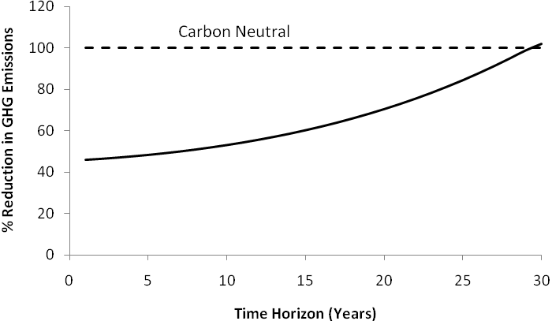

Conclusions
Ethanol for use as an alternative to crude-based transportation fuels has been a controversial topic on both environmental and economic grounds. The results of our paper show that if an acre of land is considered for production of ethanol and corn stover is used as an additional feedstock, a 5% yield improvement caused by biochar application is sufficient for the biofuel pathway to be considered carbon neutral. This has significant implications for U.S. energy policy and the broader global community concerned with issues regarding climate change.

References
Environmental Protection Agency. Renewable Fuel Standard Program (RFS2) Regulatory Impact Analysis. Washington D.C.; 2010. EPA-420-R-10-006.

Environmental Protection Agency. Regulation of fuels and fuel additives: Changes to renewable fuel standard program; final rule. Federal Register 2010;75:58.

Wright M, Daugaard D, Satrio J, Brown R. Techno-economic analysis of biomass fast pyrolysis to transportation fuels. Fuel 2010;89:S2-S10.
Lehmann J, Gaunt J, Rondon M. Bio-char sequestration in terrestrial ecosystems—a review. Mitigation and adaptation strategies for global change. 2006;11:395-419.

