on the economics of decentralized battery-supported Photovoltaic Systems

Albert Hiesl, Vienna University of Technology, +43 1 58801 370371 , hiesl@eeg.tuwien.ac.at
Reinhard Haas, Vienna University of Technology, +43 1 58801 370352 , haas@eeg.tuwien.ac.at

Overview

In recent years PV-electricity has become an increasingly competitive energy source for decentralized use. With increasing retail electricity prices and decreasing feed-in tariffs, the rate of self consumption of PV-electricity is an essential parameter for the profitability of PV-systems. Decentralized battery storage systems are one solution to increase the rate of self consumption, but are rather expensive so far. This paper focuses on the economics of decentralized PV-systems in combination with batteries. The core objective is to identify the maximum additional investment costs of battery systems to be profitable for households in Austria. Scenarios for future developement of household electricity prices are also considered as different sizes of PV- and battery systems.

Methods

Based on measured data of horizontal irradiation and ambient temperature, the PV-output is calculated following the approach suggested by Huld (Huld et al, 2010). The PV-output can be calculated depending on the direction and installation angle of the PV-modules. The electricity consumption of households are implemented as standardized load profiles (H0, BDEW) and are scalable with the yearly electricity consumption. The battery is modeled as lithium battery with a typical loading gauge, an efficiency of 0.9 and a depth of discharge of 0.8, which means that the effective capacity is 80% of the nominal capacity. The PV-output, the load profile as well as the parameters of the battery are input parameters for the optimization model implemented in MATLAB. The optimization model, which is based on the YALMIP toolbox and the GUROBI solver, decides when to charge or discharge the battery, when to purchase electricity and when to feed in the PV-surplus. The objective function of the model is to minimize the costs of electricity purchase and the calculation is done for 25 years with different PV- and battery capacities. The outpout parameters of the optimization model are input parameters for the economic calculation (cost savings due to self consumption and revenues due to electricity feed in) to calculate the maximum additional battery investment costs . As the energetic output of the PV-system and the storage capacity of the battery decreases over lifetime, the rate of self-consumption as well as the coverage of the load profile changes. In the calculation, the lifetime of the PV-System is assumed with 25 years and the lifetime of the battery with 12,5 years. The energetic degradation of the PV-System is set to 1% per year. It is assumed, that the battery can do 3000 cycles with a depth of discharge of 80%. With 200 – 250 load cycles per year, the battery would last for about 12-13 years and the battery has to be changed once during 25 years. It is assumed, that in this period the investment costs of battery systems drop to 70% of actual investment costs and these additional costs are also considered in the calculation. The economic calculation is done as follows:

$$NPV= -I_{batt, ges}+ \sum_{t=1}^{25}{\frac{∆C_{t}}{{\left(1+r\right)}^{t}}}=0$$

$$I_{batt, ges}= \sum_{t=1}^{25}{\frac{∆C_{t}}{{\left(1+r\right)}^{t}}}$$

$$I_{batt}= \frac{I_{batt,ges}}{1+0,7*{\left(1+r\right)}^{-13}}$$

$∆C_{t}$ is the difference of the cash-flows (cost savings + feed in revenues) in year t with and without battery. C_{t} strongly depends on the amount of self-consumed PV-electricity ($q^{self consumption}$), household electricity prices ($c^{electricty purchase}$) , feed-in tariffs ($p^{feed in}$) and the amount of PV-electricity which is fed into the grid ($q^{feed in}$).

$${C_{t}=q}^{sel{f consumption}_{}} *c^{electricity purchase}+q_{}^{feed in}*p^{feed in}$$

With assumptions on the future developement of household electricity prices and feed-in tariffs, the additional investment costs for the battery (I_{batt}) are calculated for specific interest rates .

Results
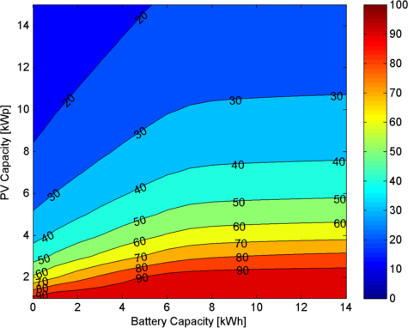
The following figures show results based on a PV-system located in Vienna with an installation angle of 30° and southward orientation. The standardized load profile of the household has been scaled with a yearly electricity consumption of 4000 kWh.
As one can see in Figure 1, the rate of self consumption increases significantly with the size of the battery. From an energetic point of view, the size of the battery should be around 6-7 kWh. A further increase would not achieve much more benefit.
The possible cost-savings due to PV-self consumption can not be calculated with the overall household electricity price, because only the kilowatt-hour rate is responsible for this savings. When we look at the Austrian electricity price of 21c/kWh, only 16.5c/kWh can be considered for cost-savings. The feed in tariff for this calculation is set to 8 c/kWh.
Figure 1: Rate of Self Consupmption [%]

Economic calculation for an interest rate of 1% and a price increase of 2% p.a.
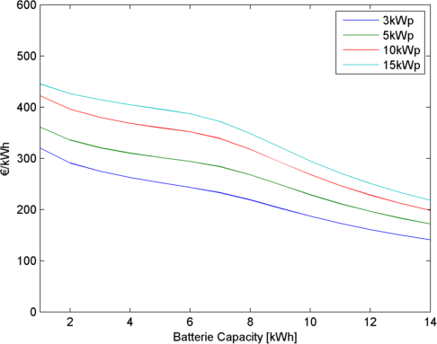
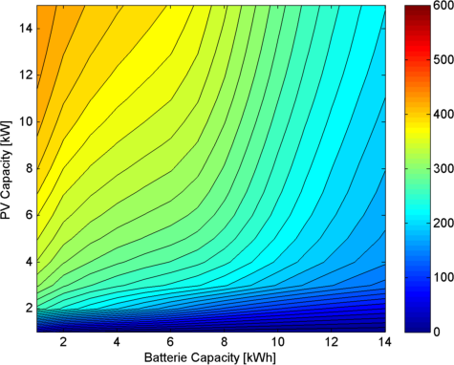

Figure 3: Battery Investement Costs [€/kWh]
Figure 2: Battery Investment Costs [€/kWh]
As one can see in Figure 2, the maximum additional costs are below 50 €/kWh for small PV-Systems where the rate of self consumption is above 90%, also without a battery storage system. The additional costs in this szenario lie between 3 €/kWh for a 1kWp PV-system combined with a 14 kWh battery storage and about 445 €/kWh for a 15 kWp PV-system and a 1 kWh battery storage system. Figure 3 shows the sections of four PV-sizes more in detail. As one can see, the investment costs decrease more quickly at a battery capacity above 7 kWh. This is the point where a further increase of battery capacity would not achieve much more benefit in case of self consumption.

Conclusions
From a household’s point of view, there is no economic benefit from a combined PV-storage-system with actual battery investment costs of approximatly 2000 – 3000 €/kWh. Depending on the scenario the investement costs for a battery system should be significantly below 600 €/kWh, to be beneficial for households.

References
Huld, T., Gottschalg, R., Beyer, H.G., and Topič, M. (2010). Mapping the performance of PV modules, effects of module type and data averaging. Sol. Energy 84, 324–338.

