Portfolio Analysis of Renewable Energies

Mehdi Shahriari, Pennsylvania State University, Phone +1 814 441 5180, E-mail: mehdi@psu.edu
Seth Blumsack, Pennsylvania State University, Phone +1 814 863 7597, E-mail: sethb@psu.edu

Overview

We develop a measure for evaluating the economic performance of portfolios of spatially distributed variable renewable power generation resources (such as wind and solar power) that is inspired by classical approaches for financial portfolio analysis. Our approach of analysing renewable energy portfolios measures how an individual asset will behave relative to a portfolio of similar assets, similar to the ‘beta’ used to measure co-movements between an individual equity’s share price and the value of the broader market. Our definition of the “renewable energy beta” decomposes these co-movements into correlation between an individual renewable site and a portfolio of sites, and the volatility of an individual site relative to a portfolio. While the financial beta is usually used to measure co-movements of share prices, our renewable energy beta can be used to measure co-movements in power generation and revenue between a single site and a portfolio of sites across both time and space.

In this study, we apply our beta concept and variance decomposition to two types of renewable energy portfolios: wind farms and run-of-river small hydrokinetic turbines. Revenue of assets rather than returns from assets have been used to calculate beta values. These beta values could be used for analyzing the portfolio and assessing the risk associated with each individual asset. Furthermore, revenue variance can be decomposed into several parts to analyze the effect of power variance, price variance and power-price co-fluctuations on revenue variance. This will enable us to compare market and meteorological elements that affect beta. Overall, beta and variance decomposition would determine level of risk associated with each asset and would be helpful in addressing problems associated with low correlation and high volatility within a portfolio of renewable energies.

Methods
Revenue of a renewable site is the product of power and price. We derive a variance decomposition that allows us to separate the influence of power fluctuations, price fluctuations, and co-fluctuations on revenue variance. We can thus determine the main factor that influences beta values: market factors (price) or meteorological/environmental factors (power).

By assuming that an individual asset is a windfarm or a hydrokinetic site, beta is defined as:
$Beta_{i}=\frac{Covariance\left(i,P\right)}{Variance\left(P\right)}=Correlation\left(i,P\right)*\sqrt{\frac{Variance\left(i\right)}{Variance\left(P\right)}}$$Beta_{i}=\frac{Covariance\left(i,P\right)}{Variance\left(P\right)}$
P identifies the portfolio and i shows an individual asset. Therefore, beta for a single asset is defined as the covariance between revenue of that asset and the revenue of a portfolio (consists of all other sites) divided by revenue variance of the portfolio. Furthermore, we can say that beta is comprised of two terms: correlation and volatility. Volatility is simply the relative variation of an asset’s revenue to the portfolio’s revenue. For this study, we use a fine-grained spatial and temporal river model to simulate the performance of distributed hydrokinetic sites in the Guadalupe and San Antonio River Basins. The study area for wind analysis covers the US Eastern Interconnect and includes more than 1300 simulated windfarms, with data taken from the NREL Eastern Wind Interconnection and Transmission Study.

Results
The variance decomposition analysis will show how price and power influence revenue. The results suggest two contrasting outcomes: 1- revenue variance of hydrokinetic sites, at least within a river basin, are mainly affected by price variance, 2- revenue variance of windfarms are mostly influenced by power variance.

Beta values for hydrokinetic sites are all close to 1, indicating a high degree of correlation between price and power output, and low variation in relative volatility among hydrokinetic sites. For wind analysis, beta values have been studied at different geographical scales to find out how geographic scaling affects contributions of individual sites to the variance of portfolios. The range for beta values that we observe for individual wind farms is much larger than for hydrokinetics. For example, beta values range from -0.07 to 1.89 at the interconnect level. Figure 1 shows beta values for windfarms in Iowa and Pennsylvania relative to portfolios at the state, regional and continental spatial scales. Figure 2 shows the spatial distribution of beta, correlation and volatility across the eastern interconnect.
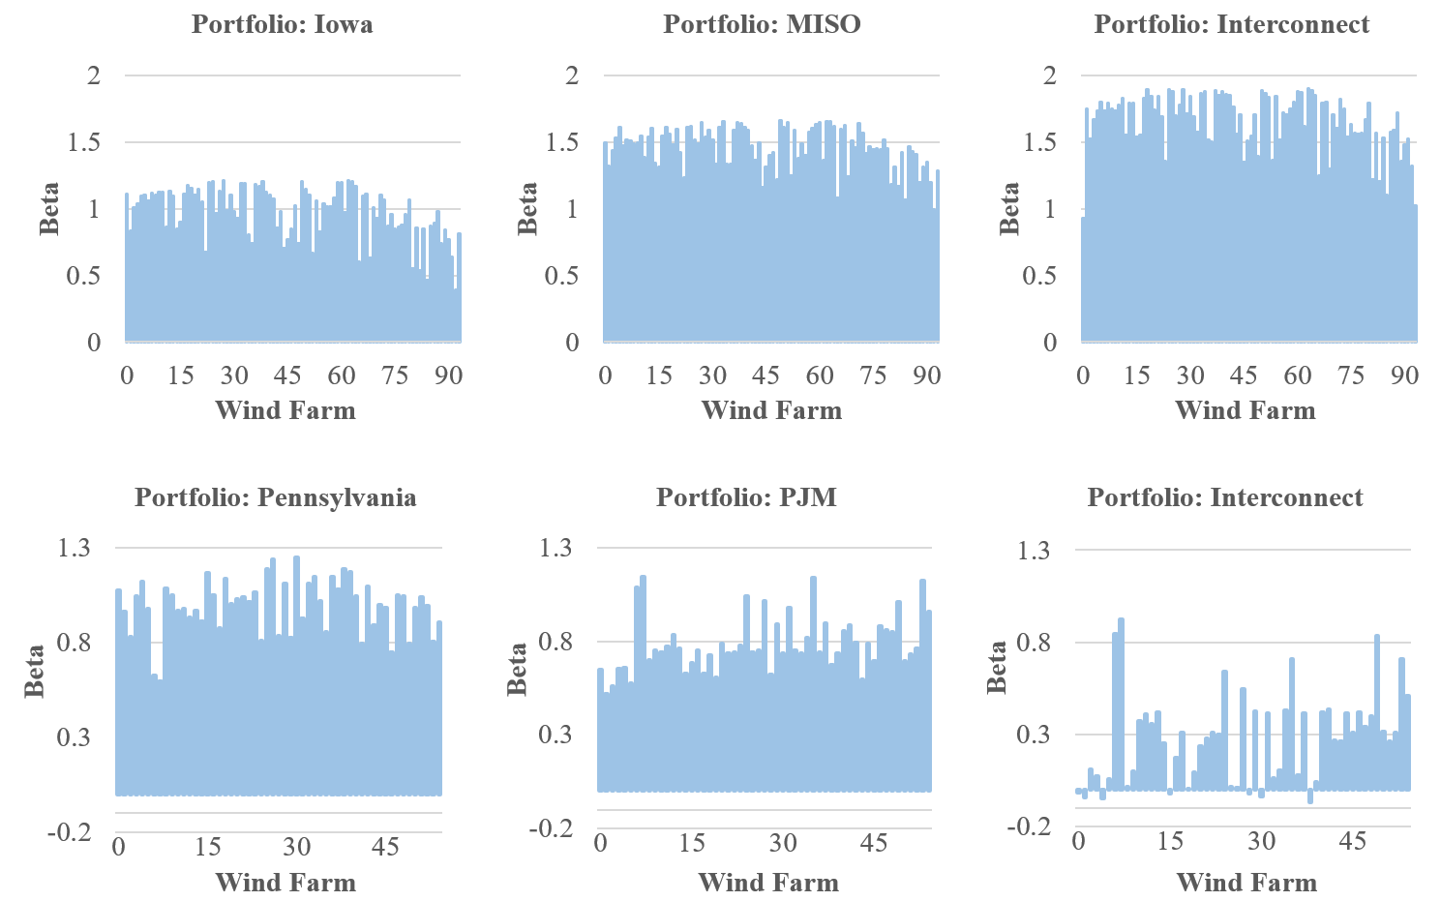
Figure 1- Beta values for windfarms in Iowa and Pennsylvania based on different portfolios. Two contrasting outcomes can be observed: 1- For wind farms with high correlation values in the interconnect portfolio, beta values increase as geographical scale increases. 2- For wind farms with low correlation values in the interconnect portfolio, betas decrease as geographical scale increases.

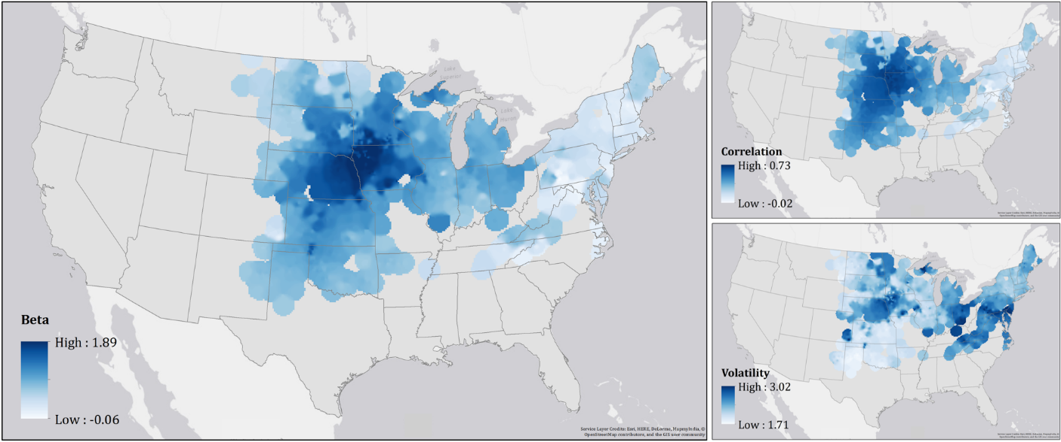
Figure 2- Beta, correlation and volatility values for potential windfarms across the US Eastern Interconnect. These maps show that correlation between a wind farm and the portfolio has a significant effect on the wind farm’s beta. Generated by using ArcGIS® software by Esri.

Conclusions
Variance decomposition analysis shows that based on the region and the nature of the renewable asset, either changes in price or power would be the main factor influencing revenue variance. In smaller regions, market elements could be more important as meteorological or environmental variation is less pronounced. In larger regions, however, meteorological and environmental factors could play bigger roles as lower power correlation is observed among individual sites.

The renewable energy beta measure can be used to assess the contribution of individual sites to the performance of a spatially distributed portfolio of renewable energy sites. Correlation and volatility determines the beta value for each site. As a general rule, a low beta could be the result of one of the following conditions: 1) low correlation between an asset and the portfolio, 2) the variance of an asset is small relative to the variance of the portfolio. A low beta value means that the asset has low returns or in our case low revenue. On the other hand, a low beta would make the asset hedgeable. It means that an individual asset with low beta value can be used to decrease the variance of the portfolio, though possibly at the cost of lower mean or peak energy production.

