Is Henry Hub Still Relevant in the Changing North American Gas Market?

Bradford G. Leach, Energy Advisory Services (EAS), New Fairfield, CT, and
Benjamin Schlesinger, Benjamin Schlesinger and Associates, LLC (BSA), Bethesda, MD

Abstract
Henry Hub is the best known of more than 100 North American pricing points. Physical liquidity at Henry Hub, however, has steadily declined. This paper considers what risks are posed by this decline, and what kinds of players need to worry about it. We review why this is happening, how it may force reorienting Henry Hub as the premier North American gas pricing location, and what the potential implications are for players throughout the global gas industry.
Located on the Gulf Coast in near Erath, Louisiana, Henry Hub intersects eleven natural gas pipelines and is the designated physical delivery location in the NYMEX Henry Hub Natural Gas Futures contract. Henry Hub is the most liquid financial gas trading location in the world, with more than 80 million gas futures contracts traded in 2014, and open interest (i.e., the value of futures contracts that have not yet closed) in excess of $24 billion as of March 31, 2015. In contrast to NYMEX contract activity, though, physical liquidity at Henry Hub has declined especially as shale gas production has advanced dramatically elsewhere in North America, and elsewhere even within Louisiana. The Marcellus, Utica and some of the continent’s other newly prolific shale fields are located far from Henry Hub, as shown in Figure 1. These developments are changing the geography of North American gas production and, with that, the distribution of physical trading liquidity.
Background: a NYMEX creation
Henry Hub wasn’t even part of the vocabulary when US gas spot markets ascended in the 1980s. With the blessing of federal regulators amidst a gas surplus, spot gas markets spread like a prairie fire across the North American continent and, by 1987, had replaced most US pipeline-sold contract gas. But with spot gas came price uncertainty and inherent volatility risks, so the need for a corresponding gas futures market soon became apparent. Presciently, the New York Mercantile Exchange (NYMEX) convened gas market advisors in 1984 and began developing the world’s first natural gas futures contract.
NYMEX’s initial thinking about gas futures centered on having a physical delivery point located at the active gas market center in Katy, Texas. Nascent gas spot markets using interstate (Federally-regulated) infrastructure were only then emerging, while Texas intrastate markets were in full bloom, hence the latter seemed to pose far less regulatory risk. By 1989, however, spot gas markets had infused the continent and NYMEX shifted the proposed physical delivery point to then-obscure Henry Hub – for several important reasons:
- Physical location near high volume interstate gas flows from southern Louisiana and especially the outer continental shelf (OCS)
- Single owner of the facility, Texaco, with flat fee hub service among multiple pipelines
- Interstate pipeline Federal regulation growing increasingly fair and sophisticated.
Meanwhile, while North America’s relatively young gas trade press had already been since 1985 reporting spot gas prices at other locations, few had even heard of Henry Hub. But the impending launch of the NYMEX futures contract helped to persuade the media that the gas industry would need to refer to price data at Henry Hub. The rest is history – the NYMEX gas futures contract began trading in April 1990 and Henry Hub grew quickly to become the most highly visible gas price reference for North America.
Figure 1 Leading US Shale Gas Producing Regions
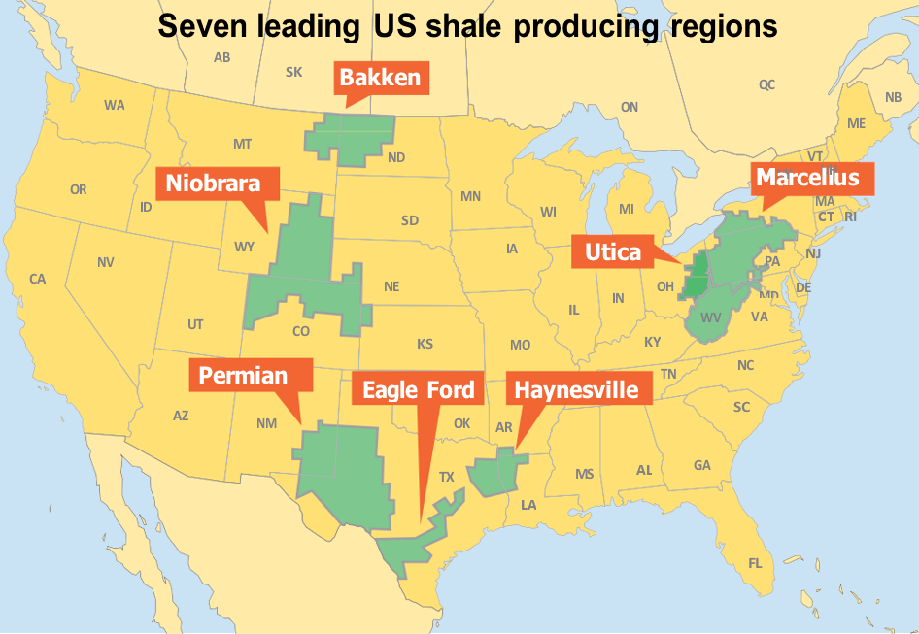
Source: EIA Drilling Productivity Report, adaptation courtesy of Gas Strategies, Ltd.

Henry Hub and more than 100 other pricing points, rising and falling
Since the late 1990s, Henry Hub has been the reference point synonymous globally with the price of gas in North America. But Henry Hub is in reality only one of more than 100 active gas hubs and pricing/trading points on the continent, and some of these others have hosted highly liquid spot gas markets for decades. For example, physical market liquidity at such gas trading points as AECO-C in Alberta, SoCal at the California border, Columbia Appalachia in the US Northeast, and at some important others has long exceeded that of Henry Hub.
Why do markets trade one hub rather than another? Many attributes draw trading activity to hubs, including location at a gas pipeline crossroads, operation by an efficient hub operator, and proximity to high volume gas production or demand centers or both, and other attributes. In the case of Henry Hub, the first of these – location at a gas pipeline crossroads – is obviously present. Moreover, Henry Hub’s owners have consistently served as efficient operators, thus clearly meeting the second attribute. But to an extent, the third attribute above, i.e., the part about high volume production, has turned more problematic for Henry Hub because OCS and Southern Louisiana gas production has declined significantly.
Prolific regional supplies were critical in defining the relevance of the Henry Hub Futures contract in the first place. In 1990, the year NYMEX launched the gas futures contract at Henry Hub, 13.4 Bcf per day was produced in Federal OCS waters. In 2014, the OCS produced 3.5 Bcf per day, thus a 74% decline. As Figure 2 shows, most gas produced in recent years in Louisiana has come from the northern part of the state, particularly in the Haynesville shales, rather than in southern Louisiana or the OCS, which are closer to Henry Hub. Indeed, shale gas in some locations outside Louisiana is today serving demands that were formally supplied by gas produced in Southern Louisiana and the OCS.
Figure 2 Natural Gas Production in On- and Offshore Louisiana, including Federal OCS, versus Northern Louisiana

Source: BSA, from EIA and Louisiana Department of Natural Resources (DNR) data.
In short, the choice of trading hub is one of maximizing market relevance, liquidity, transparency and hedging opportunities, while minimizing risks of errant pricing, supply and/or demand starvation, inconsistent information and illiquidity.
To the first point, rising gas production in the Marcellus and Utica shale formations – centered in Pennsylvania, Ohio, and West Virginia – has induced a concomitant rise in gas purchase and sales transactions at those locations. Appalachian-relevant points that were less liquid in past years, such as Texas Eastern M-2, have grown more liquid, while physical liquidity has declined at historical production locations.
The effect on Henry Hub has been striking, as demonstrated by deal counts, volumes, and Platts tiering classifications in the figures that follow: Figure 3 shows deals per month used by Platts to develop its monthly Louisiana-related price indices. Strikingly, as the figure shows, only a handful of deals underpinned the Platts monthly index in many months. Likewise, Figure 4 shows monthly Henry Hub volumes published by Platts that form the foundation of the Platts Henry Hub monthly prices. Henry’s physical decline is apparent in both charts.
Figure 3 Numbers of Transactions Underpinning Platts Physical Henry Hub Monthly Index

Source: EAS, from Platts Liquidity in North American Gas Markets.
Figure 4 Platts Henry Hub Monthly Volumes, MMBtu/day x 1,000

Source: EAS, from Platts Liquidity in North American Gas Markets.
Figure 5 Platts Henry Hub Monthly Tiers

Source: EAS, from Platts Liquidity in North American Gas Markets.

Figure 5 provides the Henry Hub tier liquidity classifications from 2005, the first full year of volume, deals, and tier reporting by Platts, through 2015. Tier 1 is the most liquid while Tier 3 is the lowest level of liquidity that Platts will accept in reporting monthly prices. This chart further documents the decline in Henry Hub physical trades as received by Platts from 2010-2015.
As a rule, then, physical trading follows the physical gas – where there are greater volumes of gas, there are greater volumes of physical gas trading, and the contrapositive – less gas, fewer trades. While linked to physical trading, financial trading in mature markets can have substantial liquidity without corresponding increases in physical trading at the financial trading reference location. High liquidity locations offer buyers and sellers more efficient trading and transaction ease. The distribution of open interest is another element of the definition of liquidity. The Intercontinental Exchange (ICE) Henry Hub futures contract has multi-year open interest in the back months of that contract, i.e., contracts for delivery beyond the first 12 months. This indicates significant commercial depth because, for many other energy futures contracts, open interest is ordinarily concentrated in the front months.

Relevance to international gas market participants
According to EIA data, shale gas has already passed the 50% mark in the US – i.e., over half the natural gas consumed in the US is from shale fields. Among these, the Marcellus and Utica shale regions together currently supply about one quarter of the entire US gas market (up from virtually nothing in 2010). At the same time, as shown above, gas produced in the US offshore and southern Louisiana has declined significantly, and is now only a marginal source of supply for the US market. The reasons for this are primarily competitive – there remain prolific natural gas resources in the producing regions around Henry Hub, and exploration and development costs have not increased precipitously. But other gas supplies (read: shale) are now being produced at far lower costs, and these other gas resources are not going away soon.
So in this environment, will Henry Hub continue to be the most visible natural gas price reference in North America? The answer is yes, because changing gas supplies and demands will leave values in southern Louisiana as important as ever. New local demands will include dozens of industrial plants that are being developed along the Gulf Coast and, soon, rising LNG exportation from nearby terminals. Supplies will include local production, which is likely to recover as demand improves, as well as gas supplies that are increasingly “imported” into southern Louisiana from prolific, low-cost shale plays such as the Haynesville, located in northern Louisiana, and the Marcellus/Utica region further to the north.
For its part, significant pipeline transportation constraints have forced gas produced in the Marcellus and Utica to be priced at significant discounts to Henry Hub – e.g., Platts April 2015 monthly market center price at Henry Hub of USD 2.53 per MMBtu is nearly double the comparable (and far more liquid) Dominion Appalachia price of USD 1.34 per MMBtu. Clearly, significant pipeline capacity constraints must be overcome for further physical and financial development of the Marcellus/Utica plays. Proposed major pipeline expansion projects will significantly increase transportation capacity from the Marcellus/Utica region to promising demand centers such as New England – and even now, relatively low-cost pipeline adjustments (flow reversals) are opening up Marcellus/Utica gas to the Louisiana Gulf Coast region. With increased transportation capacity will come more uniform gas pricing between the Marcellus/Utica and Henry Hub.
Conclusions
Henry Hub will likely remain relevant even at times when southern Louisiana increasingly serves as a transit region for feed gas from other regions bound for local industry and LNG exportation from Gulf Coast liquefaction plants. Indeed, more sources of gas supply supplementing local production will add competition at Henry Hub. This together with new demand sources like LNG exports will help balance and diversify the market, and contribute to Henry Hub’s importance as a price indicator.
Meanwhile, with decreased Henry Hub physical liquidity, it is understandable that pricing in Cheniere’s 20-year, 0.83 mtpa LNG export contract with Woodside is indexed to NYMEX gas futures contract monthly prices, rather than cash market indicators. Both NYMEX and ICE Henry Hub futures contracts are highly liquid thus we anticipate continued reliance on Henry Hub, especially as cash markets thicken for reasons discussed above.
Looking forward, markets will need to monitor potential risks of price disconnects between physical and financial Henry Hub markets, while great volume imbalances separate them. The increasing maturity of Marcellus/Utica and other shale production may encourage the development of additional region-specific risk management contracts. Opening of LNG export facilities along the Gulf Coast could revitalize the physical trading environment in that region. And there will be a need for parties holding long-term gas sales and purchase agreements (SPA) to consider with diligence the published hubs and pricing points that may be included as indices in their SPAs or other local contracts.

NYMEX is now a regulated exchange subsidiary of CME Group.
Following Chevron’s acquisition of Texaco in 2001, Henry Hub remained in Chevron’s ownership until November 2014, when Chevron sold a number of gas infrastructure properties, including Henry Hub, to Enlink Midstream.
It should be noted that Platts is one of several energy trade publishers in North America and, thereby, does not necessarily receive information about all North American gas trading volumes. Platts data are used here because Platts is publicly available on a monthly basis and has been consistent in this respect, including at this trading point and others, in some cases for three decades since January 1985.
Source: Cheniere Energy, Inc., 8-K Filing before the US Securities and Exchange Commission, Washington, DC, 30 June 2014.

