Cost and price dynamics of solar modules

Anshuman Sahoo, Management Science & Engineering, Stanford University, +1 415 742 8604, asahoo@stanford.edu
Stefan Reichelstein, Graduate School of Business, Stanford University, +1 650 736 1129, reichelstein@stanford.edu

Overview
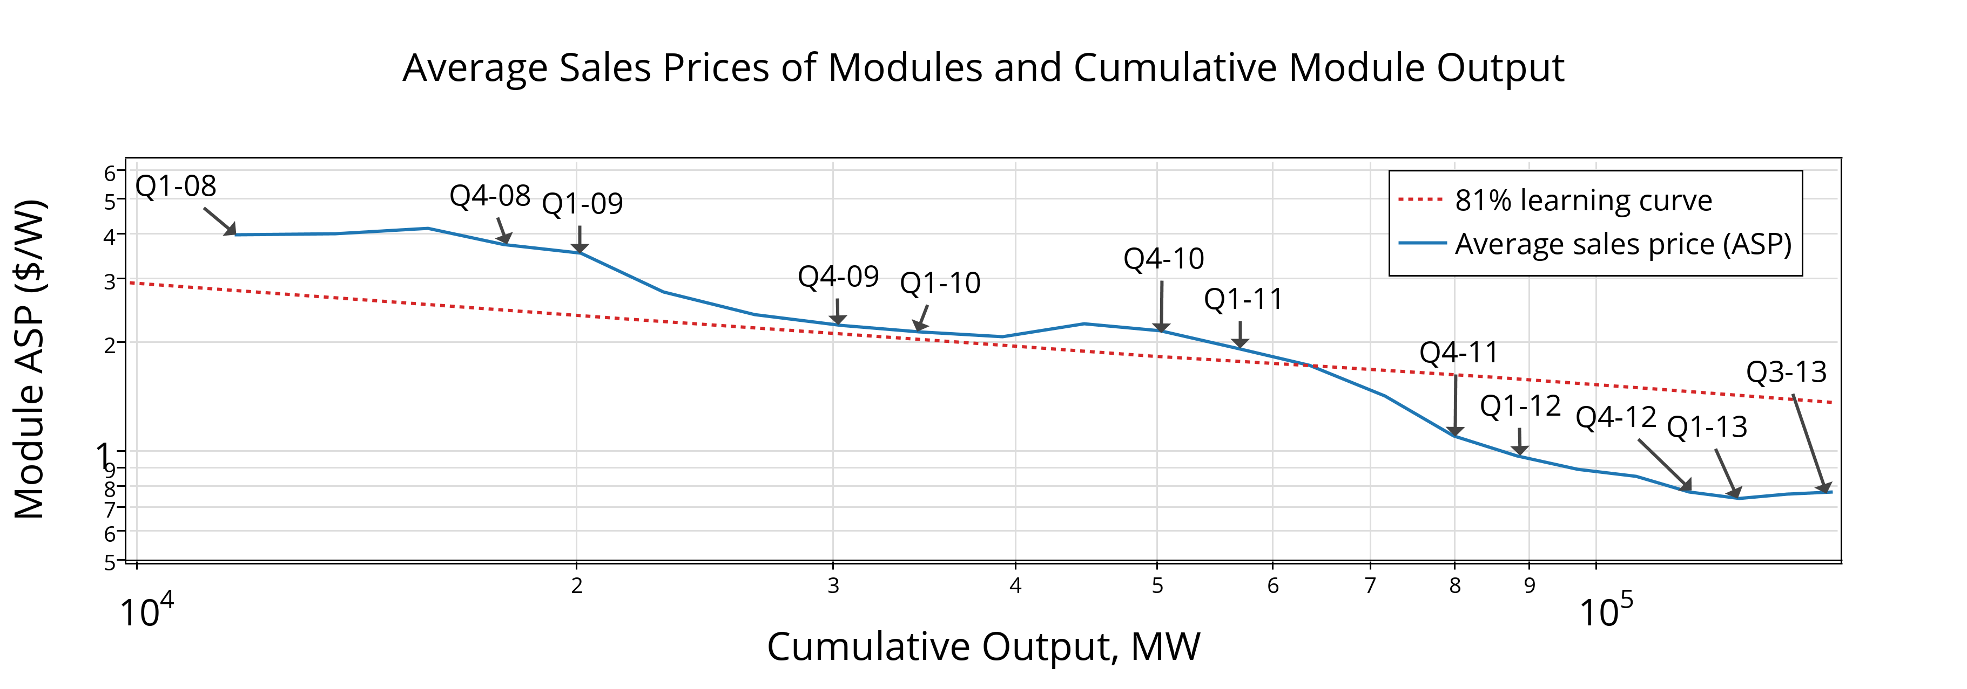Solar photovoltaic (PV) module prices have decreased significantly and consistently over the past four years. In a well-known analysis, Swanson (2011) documents that the trajectory of module prices conforms remarkably well to a pattern of an approximately 80% learning curve. However, the decline in average sales prices (ASPs) for PV modules has been even more accelerated over the last three years, as shown in Figure 1. Particularly noteworthy in this graph are the 40% price drop in 2011 alone and the most recent rebound in prices for late 2013.
Figure 1. Module ASPs have historically decreased by 19% with every doubling in cumulative module output, but recent price reductions have been much steeper.
In this work, we ask two major questions about the price and cost of solar PV modules. First, we ask if the steeper-than-expected price decreases are attributable to underlying production cost reductions or to excessive industry-wide capacity additions. Second, we apply our findings on cost dynamics to ask what the trajectory of future production costs will look like. The answer to the latter provides a benchmark of economic industry fundamentals and can be interpreted as a trend line to which equilibrium prices should converge over time.

Methods
To answer the first question, we develop a dynamic model of a competitive industry in which each firm makes a sequence of capacity investments and chooses its output levels taking market prices as a given. Given capacity constraints, the equilibrium price that emerges in equilibrium is equal to the long-run marginal cost of manufacturing and delivering one unit of output. We refer to the long-run marginal cost measure as the Economically Sustainable Price (ESP). If firms were to receive this price per Watt (W) of module outputted in each period of time, they would earn zero economic profit on their capacity investments. We compute quarterly ESPs for a sample of firms over twenty quarters and compare them with either the Bloomberg crystalline silicon solar module price index or a weighted average of ASPs reported by firms in our sample set; if price decreases were due solely to cost reductions, we would expect the estimated ESPs to equal the observed ASPs. Our estimates of ESPs are based on a product flow balance applied to quarterly and annual financial statements from the sample of firms; we access these data through the Bloomberg terminal system.
To answer the second question, we derive learning rates from our panel of ESPs. Our ESPs are decomposed into manufacturing (i.e., variable and unavoidable fixed) and capacity costs, and we estimate separate decline curves. We model manufacturing costs with firm fixed effects and estimate coefficients on cumulative output and scale. Our calculations of capacity costs are based on observations of CAPEX data from financial statements, and our estimate of a geometric cost decline parameter is from GTM Research (2012) data on capital costs for solar manufacturing equipment.

Results
We find that our ESPs generally match well with ASPs between 2008 and 2010. Though our model suggests decreases in costs and ESPs throughout the entire period observed, we also find evidence that the dramatic decline in ASPs between 2011 and 2012 is inconsistent with an industry in equilibrium. In other words, for those years, the drop in ASPs should in large part be attributed to excessive additions to manufacturing capacity rather than to cost reductions. At the end of 2012, our estimates suggest an ESP of $1.25/W in contrast to an ASP of approximately $0.8/W.
Over our study period of 2008 to 2012, we find that the ESPs declined faster than the 80% learning curve would suggest. Our ESP estimates imply an effective learning rate of approximately 75 – 78%. Upon using this rate to extrapolate the trajectory of future ESPs, we obtain a fundamental trend line to which we expect ASPs to converge. Under an assumption that the industry will continue to produce and install about 40GW annually in the coming years, the trend implies an ESP significantly above the $0.50/W goal for 2017 embodied in the original targets of the U.S. DOE SunShot Initiative.

Conclusions
Our dynamic model allows us to ask whether recent decreases in the price of solar modules are attributable to cost reductions or excessive industry-wide capacity additions. Despite large production cost reductions that are at least partly attributable to learning and scale effects since 2008, our data suggest that price reductions also reflect manufacturing overcapacity. Our expectation is that near-term ASPs will converge toward the economically sustainable price. An implication is that price projections assuming a monotonic decline from today’s prices are likely overly optimistic. Further, the capacity additions included in our projections imply module production costs above those that appear necessary to meet U.S. DOE SunShot goals.

References
Bloomberg L.P. (2013). Bloomberg database. Stanford University.
GTM Research (2012). “GTM Research PV Technology, Production and Cost Outlook: 2012 – 2016”.
Lux Research (2012), “Q4 2012 Supply Tracker”.
Swanson, R. (2011), “The Silicon Photovoltaic Roadmap,” The Stanford Energy Seminar.

Our estimates require data available from publicly-listed companies. Our sample covers approximately 25% of the 2013 manufacturing capacity. It does not include firms in the large fringe of small manufacturers; it also excludes those business units within large publicly-listed conglomerates since solar-specific data are generally unavailable.

