on Relating US and UK energy expenditures (net energy), debt, and interest rates
Carey W. King, Assistant Director - Energy Institute, University of Texas at Austin,
Phone: +1 512 471 5468, E-mail: careyking@mail.utexas.edu

Overview
Anthropologist Joseph Tainter has posited a theory on the role of energy in describing the ability of a society to organize itself and solve social and environmental problems (Tainter, 1988). Accordingly, in order to solve new problems and maintain existing services, societies tend to become more complex. In order to become more complex, societies need more energy and resources to coordinate this additional complexity. Tainter’s compelling theory (based upon pre-industrial societies), needs quantification within the context of our modern society powered by industrial energy technologies that depend upon and impact a variety of natural resources and other systems. Relating debt accumulation to relative energy expenditures is one way to quantify the ‘energy complexity spiral.’
Energy price and the total expense of purchasing end-use forms of energy act as system-wide economic indicators describing the role of energy in the broader economy. Because energy is an inelastic good and increased energy prices are passed along to other consumer goods, increases in energy price tend to reduce purchases of these more elastic discretionary goods more than energy itself (Hall et al., 2008). In the United States (US), over the past four decades since peak US oil production, economic growth was slow or the US was in recession whenever total energy expenditures were both increasing and above 10% of gross domestic product (GDP). Recent work supervised by the author suggests that the trends for the US parallel those of other industrialized economies and the world overall (Maxwell, 2013). That is to say, both the early 1980s and late 2000s were times periods of world recession or very slow growth and time periods of high expenditures of energy as a fraction of GDP.
However, high debt has played a large role in the Great Recession following the financial crisis started in 2008. It is important that we understand the relationship(s) between the cost of energy (e.g. as a fraction of GDP) and debt accumulation. This paper focuses on the US and United Kingdom (UK) economies by relating the following energy-economic aspects for those countries:
- energy prices (oil, natural gas, coal, and electricity),
- the Energy Intensity Ratio (EIR_{p}) of those energy prices (see Equation 1 below),
- the fraction of GDP for energy expenditures,
- public and private debt, and
- central bank interest rates.

Methods
Data sources are energy production, consumption, and prices from the International Energy Agency (1978-2010), Energy Information Administration (1980-2011), and from the work of Roger Fouquet particularly on historical time series (1300-2008) for the United Kingdom (Fouquet, 2008; Fouquet, 2011). Interest rate data are from the Federal Reserve of the United States and Bank of England. Debt data are from the US Treasury, Office for National Statistics for the UK, and Reinhart and Rogoff data set.
As a proxy metric for the ‘net energy ratio’ (NER) for individual energy commodities I use the calculation of the dimensionless price-based (“p”) Energy Intensity Ratio (EIR_{p}) as previously defined and used in King (2010) and Maxwell and King (2012). Equation 1 describes EIR_{p} as the ratio of two energy intensities (EI): EI_{p,n} of energy commodity n at price p is the energy content of the fuel divided by its price, and EI_{country} is the total primary energy supply (TPES) divided by the GDP of the country.
${\text{EIR}}_{p,n}=\frac{{\text{EI}}_{p,n}}{{\text{EI}}_{\text{country}}}=\frac{{\left(\text{energy content}\$\right)}_{n}}{ {\left(\text{TPES}\text{GDP}\right)}_{\text{country}}}$ (1)

While Equation (1) is an indicator for an individual energy commodity, expenditures on energy as a fraction of total country GDP is a measure of economy-wide net energy as in Equation (2). More specifically, the inverse of this fraction can be viewed as a measure of the net energy ratio (NER) ~ energy output/energy input, of the overall economy. I include food expenditures to provide a long-term perspective from preindustrial England and UK.

${\text{NER}}^{−1}=f_{e,\text{GDP}}=\frac{\text{energy }(\text{and food})\text{ expenditures}}{\text{GDP}}$ (2)

Results
Both for the US and UK there is evidence that the last decade witnessed the time period of cheapest energy and food in history as expenditures on these items, as a fraction of GDP, has increased slightly since the 2005 for the US and since 2002-2004 for the UK. Before the 1930s, the UK never spent less than 20% of its GDP for energy related to energy services (see Figure 1). Thus, the time period after the 1930s in which the UK spent less than 20% of GDP on energy for energy services is more of an anomaly than the norm.
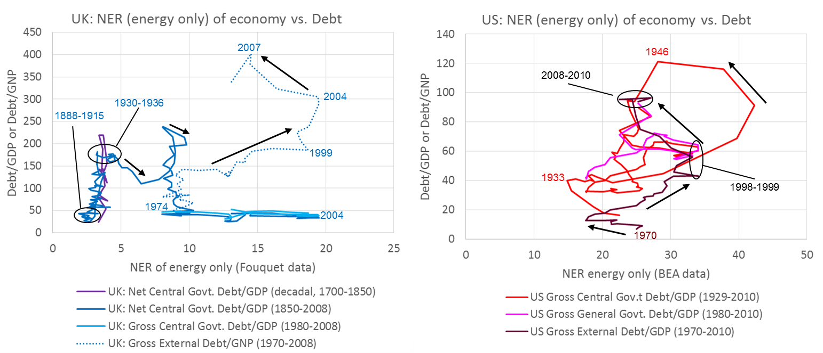
(a) (b)
Figure 1. The debt/GDP and debt/GNP ratios of the (a) UK and (b) US versus the NER economy metric when considering only energy expenditures as the boundary of interest.
The results indicate that, since 1929, the time periods of 2002-2010 and 1973-1983 stand out as time periods of increased energy (and food) expenditures (or decreasing NER of the economies) and increasing debt levels (see Figure 1). However, the 2002-2010 time period is different from that of 1978-1983 in a few important aspects:
- interest rates: while public debt and energy expenditures are high in both time periods, the interest rates reside in different regimes (high interest rates in the earlier time period and low interest rates in the more recent),
- energy expenditures: both time periods have new oil and gas resources (in the US) that became available at the end of the time periods, but the more recent time period is characterized by fundamentally higher cost marginal oil supplies from oil sands and oil shells such that today we still have high energy expenditures overall even though there are more oil reserves (that are economical) today,
- trend in energy expenditures: the time period of 1998-2005 appears to perhaps be the year of lowest energy expenditures (economy-wide cost of energy) in historical record for the US and UK, setting the context for what investments (if any) can reverse the trend of increasing energy expenditures since that time.

Conclusions
Starting several years before the onset of the Great Recession (late 2007 through late2008/early 2009), there had begun a trend of diminishing returns on expenditures for ‘food and energy’, as measured by NER, for both the US and UK economies. The fundamental long-term trend of decreasing relative expenditures for ‘food and energy’ has reversed for approximately the last 10-15 years. A similar halt in the long-term trend, but only temporarily, occurred in the 1970s and early 1980s. We might ask if the energy-economic situation of 2007-2010 is fundamentally different from that of 1973-1983. Both time periods involved oil price rises faster than economic adjustments and investments could mitigate. The two time periods of high and/or increasing energy expenditures (1973-1981 and 1998-2008) clearly stand out in the view of increasing debt. However, the last decade is unique within the history of the time period of central banking, going back 300 years for the UK, in that this high debt and high energy expenditures situation also occurs at a time of near zero interest rates.

