[REBOUND EFFECTS AND FOSSIL SUBSIDIES REFORM IN CHINA]

[Hong Li, Peking University, +86 10 62755658, lihongpku2012@163.com]
[Qin Bao, Academy of Mathematics and Systems Science, Chinese Academy of Sciences, +86 10 62545830, baoqin@amss.ac.cn]
[Liang Dong, National Institute for Environmental Studies, +81 080 4090 2595, dong0926@163.com]

Overview
China has committed a sharp reduction in its carbon intensity by 2020 and proposed to take integrated policy package including energy subsidy reform to achieve this goal. While energy efficiency improvement is the key influencing factor for this goal, its effectiveness is significantly influenced determined by rebound effect. Energy subsidy as an economic regulation policy significantly affects rebound effect, especially for developing countries like China. While, yet up to date, few studies has investigated this topic (Li and Dong, 2013). Under this circumstance, this study conducts a comprehensive evaluation on how the fossil subsidies reform in China would affect its rebound effect, by applying a multi-sector Computable General Equilibrium (CGE) model for China. Rebound effects at different technical improvement levels are investigated and further the mitigation effects on rebound effects and socio-economic impacts of subsidies reform are analyzed. The results provide significant policy insights and would be critical for China’s future low-carbon policy making in the future.

Methods
In this study, we apply a modified CGE model based on (Bao et al., 2013) which contains 40 sectors and commodities. There are 6 fossil energy resources and 4 different sources of electricity. We set four basic modules including production module, international trade module, income and expenditure module, and design a special energy subsidy module to capture the energy subsidy reform policies.
The energy subsidy module depicts how energy subsidy policy is implemented and how energy subsidy reform strategy would be carried out. To capture energy subsidy, we use subsidy_{ei} to denote the subsidy rate of energy ei. It is assumed that energy subsidy reform would reflect in the output price change of energy sector (Liu and Li, 2011), as shown in Eq(1).
PX_{ei}*(1-subsidy_{ei})=(1+itax_{ei})*PP_{ei} (1)
Where PX_{ei} and PP_{ei} are the product price and output price (exempt tax), and itax_{ei} is the production tax rate.
In this module, when subsidy_{ei}=0, it means no energy subsidy reform, and the price would be kept at current level. When subsidy_{ei} >0, it means that energy subsidy reform is implemented in the form of removing the current energy subsidy. When subsidy_{ei} <0, it means that energy subsidy reform is implemented in the form of increasing the current energy subsidy. It can be easily concluded that by removing energy subsidy, the output price would be increased, while by increasing energy subsidy, the output price would be decreased.
The energy subsidy reform policy carried out by government would affect its income and expenditure, as well as budget saving. For simplicity, in all simulations, we take the important assumption to fix government savings or deficit and assume that the benefit from energy subsidies reform will be used by government for its overall expenditure.
The energy subsidy rate for fossil energy in China was estimated by Liu and Li (2011) and Li et al.(2013), including coal, oil and natural gas by applying the price-gap approach. In this study, we use the estimated fossil energy subsidy rate, with coal and coke 6.46%, gas 35.46% and oil 19.52%.
Based on (Wei, 2010), we define five rebound conditions as follows: E0 denotes the initial market equilibrium quantity of energy, and E1 denotes the theoretical quantity of energy with an energy efficiency parameter λ(technology advancement ratio), we have E1=E0*(1-λ). If E2 denotes the actual market equilibrium quantity of energy with an energy efficiency parameter λ, then the rebound coefficient RE can be defined by:
RE=(E2-E1)/(E0-E1) (2)
By definition, five rebound conditions can be stated as: (1)Backfire effect: RE>1. (2)Full rebound: RE=1. (3)Partial rebound: 0<RE<1. (4)Zero rebound: RE=0. (5)Super-conservation: RE<0.

Results
By appling the CGE model, comprehensive evaluation of China’s fossil energy reform on rebound effect is conducted. The results for rebound effects can be concluded as follows:
Firstly, China had a partial rebound effects under different technology advancemen, with the rebound rate at about 83.3% to 95.8%. The rebound effect will vary with different technology improvement circumstances, but the differences are not quite large. Moreover, the rebound effects for different energy sources are different, and the electricity has a larger rebound effect. The rebound effects could be directly related to the relative price changes, and with a larger decrease in demand price, the rebound effect would be greater.
Secondly, energy subsidy reform would significantly mitigate the rebound effect for all policy scenarios. If remove all the coal related subsides, the general rebound effect would be reduced from 95.8% to 61.7%. If remove all the oil related subsidies, it would be reduced by about 88.67%. If remove all the gas related subsidies, it would be reduced by about 11.30%. Moreover, if we remove all the fossil energy subsides, the general rebound effect would be reduced by 102.5%, to -2.4%, which means a super conservation, i.e., energy efficiency improvement would lead to much more energy consumption reduction than expected .
Thirdly, The increment of clean energy subsidy would be effectively to mitigate rebound effect. When taken an additional clean energy subsidy into consideration, in all cases, the rebound effect would be greatly reduced.
Moreover, an integrated policy with removal of fossil energy subsidies and increment of clean energy subsidies also show its advantage in bringing more benefits for both economy and environment.
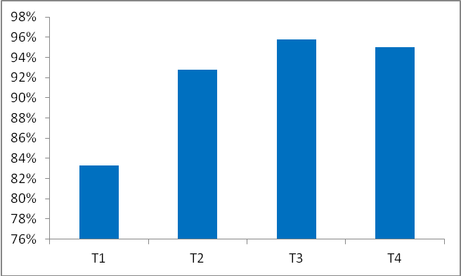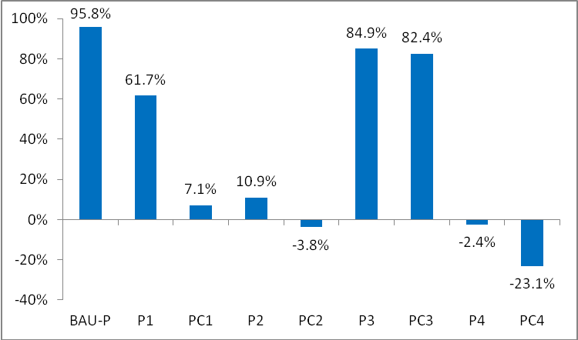
(a) (b)

Conclusions
In this paper, we studied China’s rebound effects in different energy efficiency improvement levels by using a general equilibrium model. We study how to mitigate rebound effect by energy subsidy reform. By simulation, we propose that a synthesized energy subsidy reform that includes both removing fossil energy subsidies and adding clean energy subsidies would better mitigate rebound effect, while at the same time help increase the economic growth and social welfare, while decrease carbon emissions and energy using. Therefore, we suggest a synthesized energy subsidy reform plan to achieve better result.
Based on our analytical results, several policy implications are proposed and emphasized:
Firstly, rebound effect is not only driven by the economic growth, but the industrial structure as well. Thus the mitigation measures should incorporate and bind technological, fiscal, and structure adjustment issues together.
Secondly, the reform of removing subsidies should be executed in cooperation with appropriate redistribution mechanism on economic benefits coming from increased energy efficiency, and other policies such as environmental taxation.
Thirdly, energy subsidies have been highly controversial for a long time in that they distort the energy price and indirectly harm the environment, hence it become a worldwide trend to decrease or eliminate it. However, reform should not only target on its environmental effects, but also the comprehensive social-economic matters such as how it would affect the macro economy, households living, and the interconnection among each industries.

References
Bao, Q., Tang, L., Zhang, Z., Wang, S., 2013. Impacts of border carbon adjustments on China's sectoral emissions: Simulations with a dynamic computable general equilibrium model. China Economic Review 24, 77-94.
Li, H., Dong, L., Wang, D., 2013. Economic and environmental gains of China's fossil energy subsidies reform: A rebound effect case study with EIMO model. Energy Policy 54, 335-342.
Li, H., Dong, L., Xie, M., 2011. A Study on the Comprehensive Evaluation and Optimization of How Removing Gas and Electricity Subsidies Would Affect Households' Living. Journal of Economic Research 2, 100-112.
Liu, W., Li, H., 2011. Improving energy consumption structure: A comprehensive assessment of fossil energy subsidies reform in China. Energy Policy 39, 4134-4143.

