[Quantify Benefits of Home Energy Management System under Dynamic Electricity Pricing]
[Jingjie Xiao, School of Industrial Engineering, Purdue University, xiaoj@purdue.edu]
[Dr. Andrew L. Liu, School of Industiral Engineering, Purdue University, andrewliu@purdue.edu]
[Dr. Joseph F. Pekny, School of Chemical Engineering, Purdue University, pekny@purdue.edu]

Overview
Retail electricity rates have been kept flat for the past century due to the lack of advanced metering technology and infrastructure. The flat-rate structure prevents consumers from responding to the fluctuation of actual costs of electricity generation, which varies hourly (or even minute-by-minute). The absence of demand response leads to an electricity system that is overly built with costly assets, solely to maintain system reliability. One of the core visions of the future electricity system, referred to as Smart Grid, is to use advanced metering infrastructure (AMI) and information technology to enable dynamic electricity rates,
Infrastructure and IT alone, however, are not sufficient for the widespread application of dynamic pricing structures and residential consumer participation. At least two barriers exist for the implementation of dynamic pricing. The first barrier is the lack of consensus on what a good rate structure is [2]; while the second is the difficulty of consumers’ behavior change. As most consumers have long been accustomed to a flat rate of electricity, it would take a long time for them to learn to track and respond to dynamic electricity rates, if they decide to do so at all. It is argued that the business case for Smart Grid should work with or without consumers’ behavior change [3].
To address the second barrier, home energy management systems (EMS) have emerged to help better enable residential demand participation in Smart Grid. Such devices can realize two-way communications between consumers and system operators (utilities, ISOs, etc) in terms of energy use and electricity rates, and can be programmed to control certain household appliances, such as air conditioners, dishwashers and PHEV charging. One of the main goals of this paper is to present an approximate dynamic programming (ADP) [4]-based modeling and algorithm framework that can make these systems capable of optimally managing the appliance usage using the information of anticipated whole electricity prices. The other goal of the paper is to use the modeling framework to provide numerical evidence to the debate that if dynamic rate structure is superior than the current flat rate structure in terms of reducing peak demand and overall electricity costs.

Methods
Our ADP model considers the hourly energy balancing and operating to minimize the expected electricity generation cost for an entire day, with full demand participation enabled by EMS. The full demand participation allows system operators to decide the best start-time for charging PHEVs given the due time by which the vehicle needs to be ready for use, and hence, empowers consumers without sacrificing their convinience.
ADP is introduced to solve large-scale, stochastic problems that involve decision-making over multiple time periods. The major advantage of the ADP approach over the traditional dynamic programming is that the former overcomes the curse of dimensionality, and hence, is amenable to solve problems with large dimensions in decision and state variables (Powell [4]),. In ADP, the value function needs only be apprxomiated and is updated iteratively around the post-decision state to “learn” the dynamics and to try to derive a better deicison. The post-decision state is defined as the state immediately after a decision or an action is taken and before the exogenous information becomes available. In each iteration, a particular sample path of the uncertainties is generated from Monte Carlo simulation, and the best value function approximation obtained so far is used to make decisions. At the end of each iteration, the value function estimates are updated through solving a series of linear programs.
In this work, we define the post-decision state as the backlogged PHEV charging demand (or the remaining undispatched PHEV electricity usage) because it could affect the total cost in the future periods. We further assume that the value function approximation is piecewise-linear. More specifically, we assume that 1) the cost of being in a post-decision state increases monotonically with regard to the backlogged electricity usage; 2) the slopes of the functions are also monotonically increasing. The second assumption is equivalent to state that with more backlogged demand, the marginal cost of electricity of holding one more unit demand increases. The intuition is that after filling up the low-electricity-price periods, PHEVs have to be charged in more costly time periods.
At each iteration for each hour, we start with a pre-decision state consisting of system demand, hour-ahead forecast wind output, and backlogged PHEV electricity usage, which are all the pieces of information needed to make the decisions. The dispatch decisions for both generation and vehicle charging are determined to meet the system demand, while minimizing electricity generation costs incurred in the current hour and the dispatch decisions’ impact on future systems’ costs, estimated by the value function approximation. After the actions are taken and the real-time uncertainties (such as wind output), are realized, the economic dispatch problem is solved again to obtain the ex-post electricity price (i.e. the dual of the power balance constraint), which is later used to update the gradient of the value function approximation.

Results
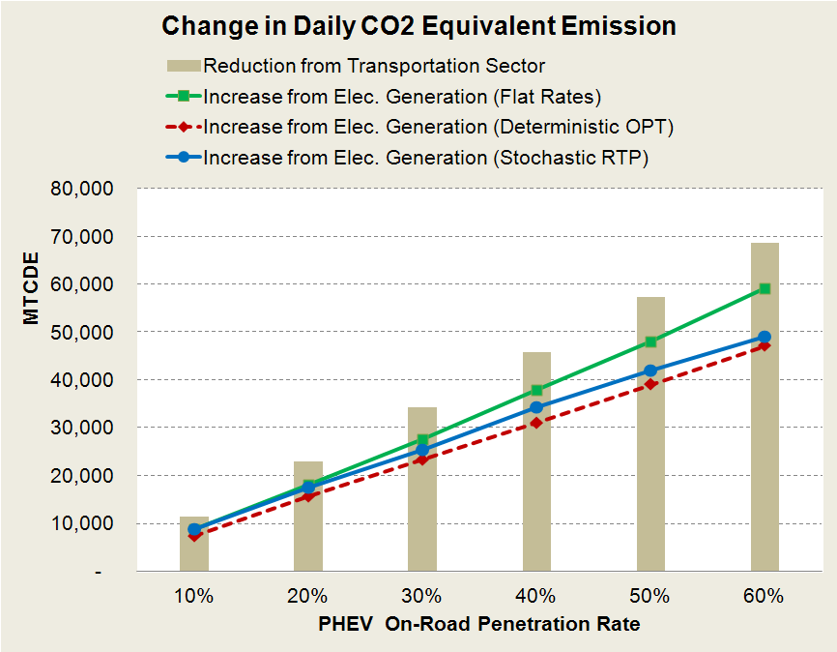
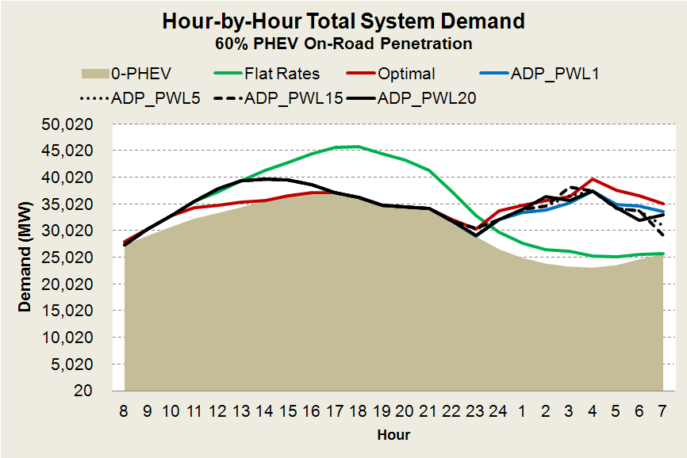
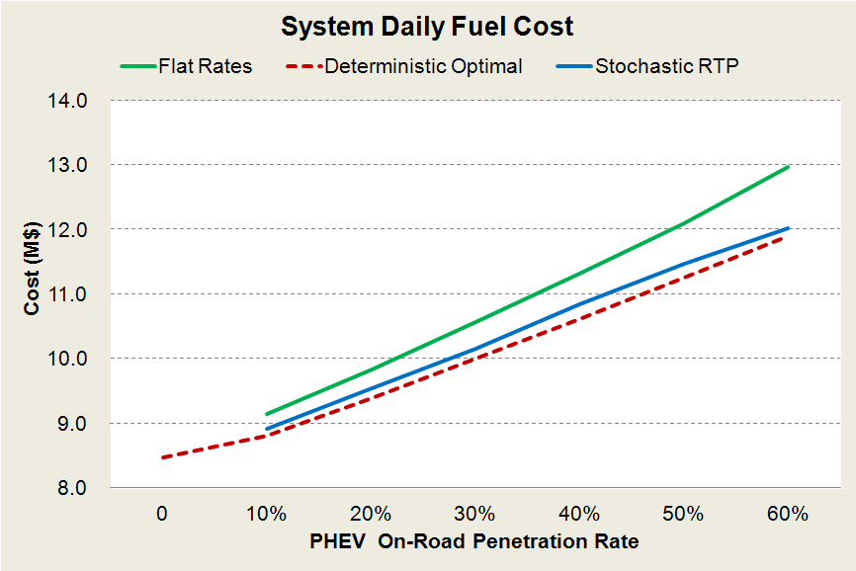
The model has been tested on a large-scale case using data from California’s electricity and transportation sectors. A highlight of the case study is the simulation of demand from PHEV charging, which is generated by combining a GIS (Geographic Information System) transportation model (in this case, we used TransCAD) and agent-based simulation [5]. The transportation model takes socioeconomic data and road networks information as inputs, and produces hourly vehicle trip information, which is then fed to an agent-based simulation (ABS) model that simulates the aggregated PHEV charging patterns that are inputs to the ADP model. This simulation approach is particularly useful and flexible to model emerging technologies that do not have historical energy output/consumption data that can be used to generate forecasts statistically. The parameters for PHEV used in our ABS model such as electricity range, electricity consumption for a full charge, and charging duration reflect characteristics of the Chevy Volt. The wind output forecasts are obtained through time-series methods using simulated wind data from NREL’s Western Wind Dataset. The demand data are available from California ISO Open Access Same-time Information System (OASIS). Finally, the generation characteristics such as nameplate capacities, heat rates and emission rates, for 107 largest natural gas power plants in California can be found in eGRID database (EPA).
The ADP problem involves solving O(IT) linear programs of variables of size O(J+K) and constraints of size O(J) where I, T, J and K refer to the number of iteration, periods, non-renewable power plants, and parameters (or blocks) for the piece-wise linear value function approximation, respectively. The ADP problem was solved within 10 minutes using Matlab. The results for the deterministic case shows that the ADP solution is very close to the true optimal (that is obtained through solving a deterministic linear optimization problem with perfect foresight) even when the approximation is simply linear. The ADP model is then applied to a stochastic case study for California to examine the system-level impacts of deploying EMS universally when hour-ahead real-time pricing is the default rate structure compared to the flat rate structure in terms of reducing peak hour demand, daily system fuel costs, and CO₂ equivalent emissions as the PHEV penetration grows.

Conclusions
In this work, we developed an ADP based modeling and algorithm framework for modeling a multi-period power operation to meet the hourly demand over the one-day horizon, in which the electricity usage for PHEVs are optimized based on the anticipated electricity prices. The framework was tested using a real-world large-scale case based on California’s electricity market, making the findings of this paper more useful for policy makers, system operators and utilities to gain concrete understanding of the system-level benefits of full demand participation enabled by automated technologies such as EMS.

References
[1] J. Bushnell, B. F. Hobbs, and F. A. Wolak, “When it comes to demand response, is FERC its own worst enemy?” The Electricity Journal, vol. 22, no. 8, pp. 9 – 18, 2009.
[2] W. W. Hogan, “Demand response pricing in organized wholesale markets,” May 2010. [Online]
[3] S. Andersen, “Saving the Smart Grid,” Public Utilities Fortnightly, pp.33 – 39, 2011.
[4] W. B. Powell, Approximate Dynamic Programming: Solving the Curses of Dimensionality. 2007.
[5] B.-M. Hodge, A. Shukla, S. Huang, G. Reklaitis, V. Venkatasubramanian, and J. Pekny, “Multi-paradigm modeling of the effects of PHEV adoption on electric utility usage levels and emissions,” Industrial &
Engineering Chemistry Research, vol. 50, no. 9, pp. 5191–5203, 2011.

