Overview

CCS ADOPTION UNDER aLTERNATIVE MARKET CONDITIONS

Donald Hanson, Argonne National Laboratory, 630-252-5061, dhanson@anl.gov
David Schmalzer, Argonne National Laboratory, 703-266-9109, schmalzer@anl.gov
Timothy Fout, National Energy Technology Laboratory, 304-285-1341, Timothy.Fout@netl.doe.gov

Currently, electric power project experience with carbon capture and sequestration (CCS) is made feasible by utilizing captured CO₂ for enhanced oil recovery (EOR) in Texas and California. In this paper we examine the potential role of expanded CCS under an important range of scenarios. The scenarios are high and low electricity demand growth and high, reference, and lower shale gas production rates. Corresponding dynamic gas supply functions were estimated from the range of sensitiviety cases that EIA has run for AEO-2012. The high electricity demand case is constructed based on adoption of plug-in hybrid electric vehicles over the time horizon to 2050.

The analysis here is conducted within a power system context. Results are presented to address the following questions: How much CO₂ emissions reduction can be achieved through PHEV adoption? How does faster shale gas development affect CCS adoption under a CO₂ emission constraint? How is the price of electricity affected by alternative implementation policies? How much could greater CCS R&D cost reductions lower future electric rates? What are the resulting paths for investment outlays in the electric power sector?

Methods
We have estimated an equivalent load duration curve (LDC) for the U.S. market taken as a whole. Technology choice, new capacity investments, retrofits, unit operations, and retirements are all affected by the shape of the load curve that the utility faces. Non-dispatchable intermittent capacity (e.g., wind and solar) must be subtracted from the LDC. Dispatchable units are then “stacked” against the remaining load. Wind and solar tend to generate a greater portion of their power off-peak, leading to only a small capacity credit. Also, the shape of the LDC tells the model when large quantities of potential base-load renewable generation cannot be used and would have to be “dumped” or routed to expensive electrical storage devices. We also show a sensitivity case with investment in some future storage technology.

The economic analysis and market simulations are done using the All Modular Integrated Growth Assessment (AMIGA) system developed at ANL. Key modules are the electric power supply module, the vehicle and transportation energy use module, and the U.S. natural gas supply module. This is a joint project between ANL and NETL and includes our participation in the Stanford University Energy Modeling Forum.

Results
We show that a CO₂ emissions charge of about $30 per tonne is sufficient to order generating units for least cost dispatch. But to induce investments in low carbon generation technologies would require about twice that carbon charge. Electricity prices can be kept lower for the consumer by imposing the lower carbon charge in combination with a low-carbon capacity market or direct investment incentives. We argue that this is a superior implementation design than relying only on high electricity prices that would be needed to cover full costs of incremental low-carbon capacity investments.

We also show that retrofitting existing pulverized coal (PC) units with CCS will lower the investment requirements for meeting a CO₂ target. Further, a CO₂ price in the $60-$100 range would excessively push conversion to gas generation, driving up gas prices to a range resulting in huge resource rents (difference between gas price and production costs) and a drilling frenzy. Also, improved capture and compression technologies will likely show significant reductions in on-site energy losses. The results of this technical progress will lower electric rates.

With a $30 CO₂ emissions charge, existing units retrofitted with CCS will obtain a partial generation offset due to movement up the LDC. For 162 existing units that were retrofitted by 2035 in our model simulations, on average, their generation rate after the retrofit was 8.2 percentage points higher than the year before retrofit. This increased utilization of retrofitted units offsets about 1/3 of the derated capacity (parasitic plant electric load due to CO₂ capture and compression). For example, if a unit were capacity derated by 28.2%, its generation on average would be reduced by 20%, the difference being the increased utilization of the retrofitted unit with lower CO₂ emissions. The 8.2 percentage point increase in utilization significantly increases the attractiveness of CCS.

Figure 1 shows an example graphic (fuel use in quads for both the electric power sector and end-use generation) for the case of lower electricity demand growth and reference gas supply scenario. At the bottom of the figure we show the adoption of CCS at existing PC units, moving coal use into units that have retrofitted with CCS. Next up, coal utilization declines in PC units that don’t retrofit. End-use coal increases, since many industries are ideal sized to match CO₂ capture with local geologic storage sites. CFB is a well-suited technology at industrial scale. Biomass co-firing was calibrated to AEO supply. Gas prices increase over time to sustain gas production and incentivize alternative co-production plants such as IGCC with CCS, producing electricity when needed or Fischer-Tropsch liquid fuel. Co-production plants can help meet high-valued peak electric load and the fuel production is a form of stored energy.

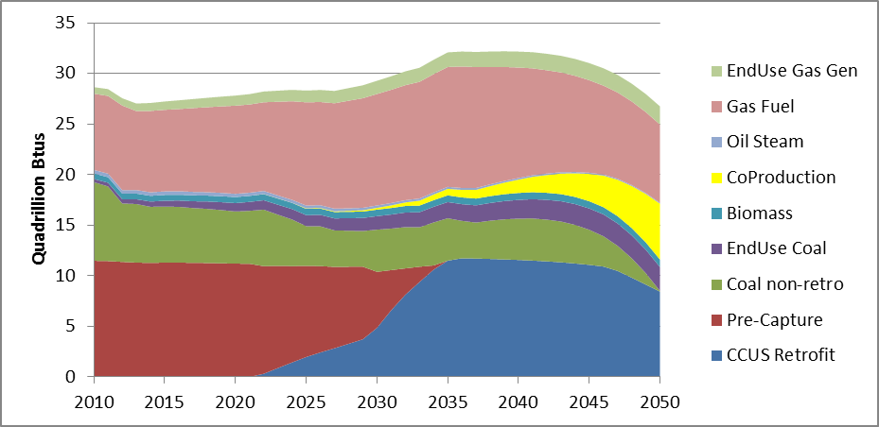

Figure 1. Fuel use for power generation (coal, biomass, gas, and oil) with 50% economy-wide CO₂ reduction requirement and under reference gas supply conditions.

Conclusions
CCS retrofits play an important role in achieving the CO₂ emissions targets. We find a need to do about the same number of PC unit retrofits in Lower or Higher Shale Gas Scenarios, given a CO₂ reduction target. With more gas, some older existing coal plants will be repowered with gas reducing CO₂ emissions, but some near-zero generation (e.g., renewables, nuclear) will be displaced on the margin with gas increasing CO₂ emissions. Balancing these offsetting effects requires about the same amount of CO₂ reduction from retrofitting existing PC plants in the alternative gas scenarios.

Imposing a carbon charge increases the demand for gas and results in a wellhead gas price considerably higher than in a comparable scenario without carbon reductions. The end-use price of gas is increased even more, adding the carbon charge to the supply cost of gas. Further, our scenario results show that if gas supply functions are shifted to the right relative to a reference gas scenario, both wellhead gas prices and the required price of CO₂ are lowered. The reverse effects are true under as low gas supply scenario.

Market-based incentives for CCS adoption are much more efficient than command-and-control regulations, letting people most familiar with plants develop least-cost investment strategies. This is because there is a lot of hard to measure unit variation: Space availability for CO₂ capture and compression; space availability for FGD upgrades and polishing units; need for other associated environmental controls; current heat rate and need for plant refurbishment; cycling ability; maintenance schedules; and system reliability planning. There exists no simple criterion to decide which units to retrofit first or to rank units in a preferred order for installing carbon capture. These decisions should be driven by experience and market incentives.

