[Mixed oligopoly competitive model of the world gas market]

[Burcu Cigerli, Rice University, 7133209432, burcuc@rice.edu]

Overview

World natural gas production is concentrated around a small number of producers, the majority of which are state-owned companies. For instance, Russia's biggest natural gas producer, Gazprom, controls 70 percent of Russian natural gas reserves and produces 78 percent of all Russian natural gas. Similarly, state-owned Sonatrach dominates natural gas production and wholesale distribution in Algeria, while state-owned Sonelgaz controls the retail distribution. These state-owned companies exercise monopoly power in their domestic markets but their actions are highly regulated by their governments. Although they have absolute power in their home markets, they compete with each other in European markets. Similarly, Russia and Qatar compete to supply Asian markets. Their market power in these foreign markets depends on their supply capacity as well as their ability to transport natural gas. On the other hand, the natural gas market in North America is the most liberalized market compared to the rest of the world. There is no monopoly producer in North America and the domestic market natural gas sales in North America are based on gas to gas contract. Therefore, we assume that natural gas producers in North America are price takers and we call them competitive fringe producers.

On the other hand, the demand for natural gas in Europe and Asia Pacific is not as concentrated as the supply side. As an approximation, we will assume that natural gas consumers (e.g. utility service providers) do not have any bargaining power and are assumed to be passive agents. This paper therefore analyzes the strategic behavior of world natural gas producers and examines the impacts of exogenous changes on their behavior.

Reflecting the fact that natural gas transport infrastructure is expensive to construct and it generally changes slowly. The high costs of developing large natural gas projects have also lead to long term contracts tying buyers to particular sellers. We therefore consider a network structure where connections between buyers and sellers are inflexible. In our model, a buyer and a seller must have a relationship, ‘link’, to trade. For instance, the Yamal pipeline from Russia to Europe is a link. The feasible trades of natural gas depend on liquified natural gas (LNG) transportation cost and the availability of pipeline connections. The cost of building pipelines over long distances and the high cost of LNG shipment lead to differences in natural gas prices between regions. In our model, however, price discrimination by producers also contributes to price differentials between markets.

We modify Ilkilic (2010) who develops a bipartite network model for m markets and n firms in Cournot competition and analyzes how the structure of the network that connects suppliers with consumers affects the market outcome. Unlike Ilkilic (2010), we assume that each producer has a supply capacity constraint and solve for the equilibrium under this constraint. We show that our game can be represented as a potential game and solve for its equilibrium. We then consider various changes to the basic model.

Methods

Taking account of strategic interaction between suppliers adds to the complexity of our model. To simplify, we therefore aggregate producers and consumers into a small number of regions.

In our model there are nine producers and nine consumers. Each producer is connected to its domestic market and out of nine producers six of them are exporters and out of nine consumers three of them are importers. The world natural gas network formed by using BP’s Statistical Review of World Energy 2010’s natural gas major trade flows is
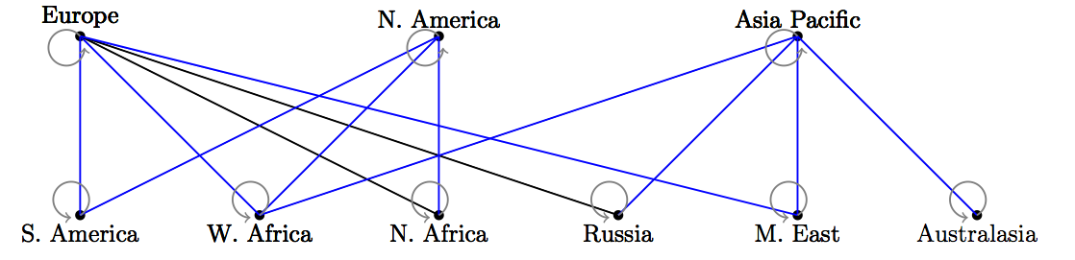

Results

In the scenario analysis section, we analyze various policy scenarios in the world natural gas market by changing the model’s parameters and/or capacity constraints exogenously. In the first scenario, we consider the cartelization of natural gas market by assuming Russia and Middle East collude to maximize their joint profit. Our preliminary results confirm that Russia and Middle East decrease their total supply to both markets they share, Europe and Asia Pacific. Next, we analyze how their attempt to exploit consumers in Europe and Asia Pacific will be affected with the increase in fringe’s supply in North America. According to our results, increase in North America’s fringe supply reduces the import demand for North America thus increase natural gas supply of non-cartel members to Europe and Asia Pacific. In another scenario, we consider the collusionof members of Gas Exporting Countries Forum and question the sustainability of such a collusion with the shale gas developments in North America.

Conclusions

This paper presented a network model of the world natural gas market which consists of consumers, producers (of which are represented as strategic Cournot players or competitive fringe producers) and links connecting them. By using natural gas consumption, production, trade and price data in 2009, we calibrated the model parameters. This allowed us to quantify the strategic interactions among natural gas producers.

As an implication of imperfect competition in this given network structure, we find that any exogenous change affecting Europe has an offsetting effect in Asia Pacific as two big producers, Russia and Middle East, are connected to both markets. We also find that shale gas development in North America reduces natural gas producers' market power all around the world.

We also find that if a natural gas producer has access to a market then her market power at that market depends on her production capacity and her costs of exporting natural gas. For instance, Russia 's market power in Asia Pacific is low because of her high costs of exporting natural gas from Sakhalin Island to Japan. We also find that any exogenous change affecting one market impacts all other markets. This impact lessens as the number of links connecting them increases.

References
BP, BP’s Statistical Review of World Energy 2010
Ilkilic R. 2010. Mergers and Cartels in Networked Markets. Unpublished working paper.

See http://www.nord-stream.com/about-us/our-shareholders/
See Oil and Gas Directory Middle East, 2011.
Other examples include Qatar Petroleum in Qatar, Nigerian National Petroleum Corporation in Nigeria, National Gas Company of Trinidad and Tobago in Trinidad and Tobago, Pertamina in Indonesia and Petronas in Malaysia.
For instance, natural gas prices in Russia are regulated by the Federal Tariff Service of the Russian Federation.
This is also true for North America.
To make the model tractable, we need to have small number of players. For that reason, we aggregate producers and consumers based on their geographic locations as well as their role in global natural gas trade. For instance we assume that Russia includes Armenia, Azerbaijan, Kazakhstan, Kyrgyzstan, Tajikistan, Turkmenistan, Uzbekistan and Russia.
These producers are South America, West Africa, North Africa, Russia, Middle East and Australasia.
These consumers are Europe, North America and Asia Pacific.
In this scenario, these members are South America, West Africa, North Africa and Australasia.
If she does not have access then her market power is zero.

