Overview

Realising Industrial Energy Efficiency: A Motivation - Capability - Implementation - Result Approach

Kah-Hin Chai., Department of Industrial and Systems Engineering, National University of Singapore, +65-6516-2250, iseckh@nus.edu.sg]
Catrina Yeo, Energy Studies Institute, National University of Singapore, +65-6516-1456, esiyklc@nus.edu.sg]
The efficient use of energy has been a focus of policymakers in many industrialized countries since the 1970s oil crisis. Energy efficiency is widely regarded as the most cost effective tool to battle carbon dioxide (CO₂) emissions and hence climate change. It is one of the most preferred priorities for industrial energy policies as the industrial sector is generally much more energy intensive than other sectors and has a need to maintain economic competitiveness. However, despite many years of trying, numerous researchers lament that the potential of energy efficiency remains untapped.
Much of the academic and policy research for industrial energy policy had focused on improving energy efficiency by addressing the infamous energy efficiency gap. This typically involves conducting studies to identify the barriers which inhibit the adoption of cleaner equipment and manufacturing practices, as well as learning from the experience of other countries such as Japan and those in Europe (Hendel–Blackford, Angelini, and Ozawa 2007). Given the multi-disciplinary nature of energy efficiency, it is not surprising that researchers with different backgrounds, ranging from ecology to economics, have engaged in this research (e.g. Brown 2001; Rohdin, Thollander et al. 2007; Stephenson, Baron et al. 2010; Adamides and Mouzakitis 2009) . Due to this, advice on how to promote energy efficiency differs depending on the perspective adopted. Mainstream economists have argued that the main barriers to energy efficiency are market failures such as the principle-agent problem and imperfect information (e.g. Brown 2001; Gillingham, Newell and Palmer 2009). On the other hand, non-economic researchers, such as engineers and policymakers, have conducted surveys to identify and rank the possible barriers (eg Rohdin, Thollander et al. 2007). Based on the barriers identified, solutions are proposed on how the barriers should be overcome (e.g. UNEP 2006).
Despite the myriad of studies, there remains no consensus on which barriers are the most important. The attempt to classify barriers into different categories, while interesting, reveals nothing substantially new on the nature of these barriers. With few exceptions (e.g. Wang 2008; Nagesha and Balachandra 2006), one commonality to these studies is that the barriers (or groups of barriers) were usually treated in isolation where standalone solutions were recommended to tackle the (groups of) barriers without considering the possible relationships between the barriers. As will be explained later, according to the systems perspective, such a piecemeal approach neglects the interconnected nature of the barriers and is not likely to lead to a sustainable improvement in energy efficiency. Therefore, the purpose of this paper is to address the energy efficiency problem following the systems perspective which takes into account the possible interactions between the various elements such as barriers, stakeholders and policies.
Systems thinking’s power lies in its ability as a problem solver to identify underlying the system’s structure that explains (similar) patterns of behaviour in a variety of different situations. Systems thinking requires that we shift our mind from event orientation (linear causality) to focusing on internal system structure (circular causality), as the underlying system structure is often the root cause of the problems. In the context of this study on energy efficiency, our interest is the removal or reduction of barriers to energy efficiency and we focus on a system of actors or stakeholders (i.e. industrial organizations, manufacturers, government agencies, customers and energy service companies), related polices, energy efficient technologies and practices. By adopting a systems thinking perspective, we avoid falling into the trap of assuming that barriers to energy efficiency are solely caused by factors which are unrelated to each other. More specifically, we attempted to identify possible interactions, relationships, feedbacks and delays in the system to develop a framework for improving industrial energy efficiency.
In this paper we propose a framework which categorizes energy efficiency barriers based on the stage at which the barriers exist. Inspired by systems thinking, the proposed framework has four stages, namely, Motivation, Capability, Implementation and Results, as well as a feedback loop. Using a case study, we show that following the four stages will lead to positive feedback for future energy efficiency implementations. The framework highlights the interconnected nature of the barriers and a need for policymakers to address these barriers in a holistic manner. We argue that the overall effectiveness of energy efficiency policies is only as strong as the weakest link in the four-stage framework. This differs from most prior research that addressed barriers in isolation, where a solution is proposed for each of the barriers without considering the relationship between the barriers. Our framework also offers a way to understand the roles and responsibilities of major stakeholders such as governments and energy service companies (ESCOs) in driving energy efficiency. This allows the assessment and identification of weak links in energy efficiency policies.

Methods
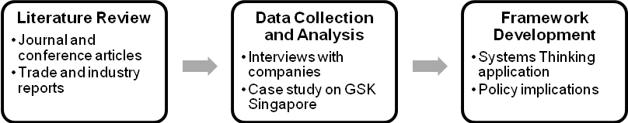
Given the relative lack of established theories from a systems perspective, a theory-building approach was adopted in this study (Strauss and Corbin 1990). In contrast to the theory-testing approach which aims to test hypotheses by using quantitative methods, theory-building or theory generation involves the formation of abstract concepts and generation by observing and reflecting real life experiences through an inductive process. This approach is commonly adopted when there is a lack of established theories in the area of research (Gill and Johnson 1991). Fig. 1 shows the research approach adopted in this study. It begins with an extensive literature review of both academic and practitioners’ publications. The second stage of this approach is data collection through semi-structured interviews with practitioners as well as by examining the relevant documents. The interview questions included: What are the challenges or barriers faced in implementing energy efficiency? How are they overcome? Are the current government measures adequate? Why? Etc. A more detailed case study was conducted with Glaxo Wellcome Manufacturing Pte Ltd Singapore, one of the companies interviewed, because of its success in energy efficiency efforts over a long period of time. We analyzed the data collected and applied principles of systems thinking in the third phase to develop a conceptual framework. It is worth mentioning that, while Fig. 1 depicts a linear research process, in reality the stages overlapped and were iterative; we refined the framework according to each new and relevant finding during the process of our research.

Fig. 1: Research Approach

Results
By and large, barriers that surfaced during the interviews were similar with those reported in literature. To sum up, there were four major observations: (1) There is a varying degree of commitment or motivation (and maturity) to energy efficiency among the companies. Drivers or motivations for energy efficiency are stronger for energy-intensive companies and those with stronger sense of corporate social responsibility; (2) Larger companies have more resources (time, staff and financial) and technical ability for energy efficiency investments; (3) Many (identified) energy efficiency investments are not implemented due to fear of risk to production; (4) Lack of data showing positive returns of energy efficiency pose a big barrier in sustaining energy efficiency efforts.
Analysis of the results was approached using systems thinking. It allows us to to integrate the qualitative results of data collection with the following thoughts, which led to the development of our generic framework: (1) Viewing the industrial sector as a heterogeneous “system”; (2) Interplay between technological, organizational and behavioral barriers to energy efficiency; (3) Interests and objectives of stakeholders (organizations and governments); (4) Energy efficiency adoption as a change process.
We propose a conceptual generic framework that is based on a stage-wise process with feedback. This framework, as depicted in Fig. 2 (EE is the acronym for energy efficiency), shows the adoption and implementation of energy efficiency practices as a process which comprises of four important stages, namely, Motivation, Capability, Implementation and Results, with a feedback effect. For each stage, we pose questions that capture factors affecting energy efficiency adoption and reflect the interests and objectives of stakeholders.
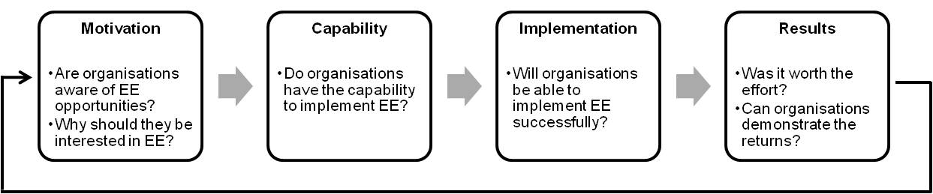
Fig. 2: The MCIR framework
Considering the interactions of barriers and the possible sequence in which they may occur, we are able to map barriers accordingly into the MCIR framework. “Motivation” barriers to energy efficiency are those barriers which lower management’s interest in pursuing energy efficiency. These barriers can be a lack of financial incentives (e.g. if energy expenses are only a small fraction of overall operating cost, lack of capital to pursue capital-intensive technology), split incentives (Brown 2001) or simply a lack of awareness of energy efficiency opportunities. “Capability” barriers can be broadly classified into technical and financial barriers. Typical barriers at this stage are a lack of information on energy efficiency technologies, a lack of trained manpower or a lack of financial resources. “Implementation” barriers are barriers that inhibit the implementation of the energy efficiency projects. Common “Implementation” barriers include resistance to change and short windows of opportunity for engineering changes given that many manufacturing organizations operate on a 24/7 basis and there is a fear of disrupting existing production processes. Barriers in the “Results” stage are widely reported but often articulated in different ways. Essentially, the lack of positive results from energy efficiency investments is a major barrier. To the organizations, results can be interpreted as economic and financial gains. By doing so, this framework can identify chokepoints of energy efficiency.

Prior to this, we had conducted a more in-depth study on how Glaxo Wellcome Manufacturing (GWM) Pte Ltd Singapore achieved energy efficiency, despite being non-energy intensive. We were able to match qualitative data from GWM’s interview to the framework (Fig. 3). This analysis shows that the framework provides a sound reasoning for energy efficiency adoption by organizations. The important lessons are: (1) Efforts must follow thorough all the stages of the framework and, (2) Level of energy efficiency adoption in an organization is only as strong as the weakest link.
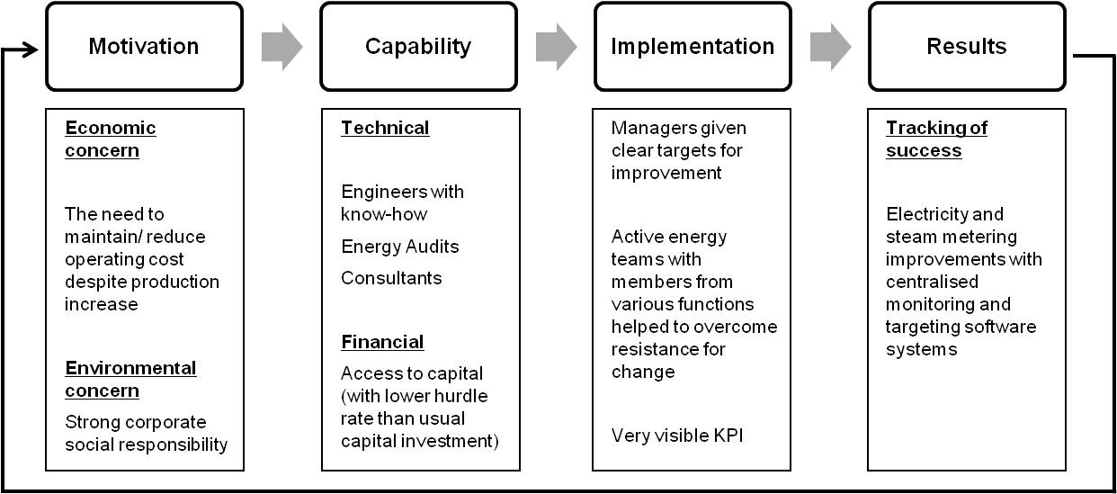
Fig. 3: Analysing energy efficiency in GWM using MCIR

At this point of our research, we also identified two possible theoretical applications of the MCIR framework. The first one involves understanding the roles of stakeholders in facilitating energy efficiency actions by companies. In this study, we identified the stakeholders as those who have a more direct influence on energy efficiency actions. They include governments, the organizations themselves, energy service companies (ESCOs) and customers. Table X shows the various measures that stakeholders may take or the influence that they may have in reducing the barriers in the respective stages in companies.
 | Motivation | Capability | Implementation | Results
Government | - Voluntary agreements  - Education & awareness  - Regulations & legislations | - Financial grants & incentives  - Provision of energy manager training | - Target setting  - Benchmarking  - Provision of network platforms  - R&D of energy efficient technologies | - Standard reporting protocol to account for economic benefits of EE improvements
Industrial Organizations | - Corporate Social Responsibility (CSR)  - Meeting employees’ expectations | - Energy audits  - Engage consultancy | - Overcome resistance to change/ alignment to values  - Target setting  - ISO 50000  - Outsourcing  - R&D of energy efficient technologies | - Energy data collection and monitoring
ESCOs |  | - Energy audits and improvement recommendations  - Sharing of best practices | - Follow up sessions  - ISO 50000  - Benchmarking  - Lean & Six Sigma | - Techniques or tools to measure and quantify benefits of EE
Customers | - Demand for “green” product (lower carbon footprint)

Table 1: Roles of stakeholders

The second application involves helping government to assess policy effectivessness. Depending on the prevalence of the type of barriers, the country could be facing “Motivational”, “Capabilities”, “Implementation” or “Results” barriers, or it could also be a combination of two or more categories. Such an analysis gives clues to the weakest link in the framework, which then aids governments to determine the type of policies to introduce. The following simplified scenario depicted by Fig. 4 illustrates how the framework may help policymakers.

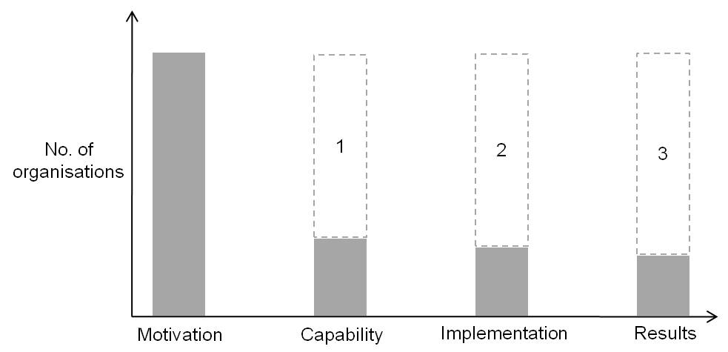

Fig. 4: Big gap between the number of organizations which are motivated and that with EE capabilities.
Possible Solutions: (1) build the ESCOs industry, provide financial grants & incentives, (2) enforce implementation, (3) monitor and track returns

Conclusions
This paper reviewed the various classifications of barriers to energy efficiency in the literature and proposed a systems thinking perspective to barrier analysis by considering interactions between the barriers and different categories of barriers. Other elements such as stakeholders and government policies were also taken into perspective, resulting in a process-oriented, sequential, closed-loop framework that was introduced to increase energy efficiency adoption. The framework, which we termed the MCIR framework, consists of four stages connected in series: “Motivation”, “Capability”, “Implementation” and “Results”. The outputs from “Results” forms a feedback loop into “Motivation” where positive results (demonstration of energy savings) sustain energy efficiency adoption. The framework also reveals that the level of energy efficiency is only as strong as the weakest link (between the stages).
Our paper makes three important contributions. Firstly, by adopting a systems perspective, our proposed holistic framework takes into account the relationship between the barriers based on the process of energy efficiency implementation. The feedback effect that existing implementation has on future energy efficiency is explicitly recognized. This is different from previous studies which traditionally treated barriers in an isolated and piecemeal manner. Secondly, our framework can be used a policy guiding tool to analyze stages which need improvements, as shown in Section 6.4. This is an important contribution because, to the best of our knowledge, it is the first systematic method for analyzing shortcomings in energy efficiency policy. Thirdly, our framework, when extended to include the stakeholders, shows the roles and responsibilities of the stakeholders involved in implementing energy efficiency. This big picture view allows policymakers to formulate policies and actions which can help to establish the necessary stakeholders so that they can contribute to the specific stage of energy efficiency.

References
Adamides, E. D., Mouzakitis, Y., 2009. Industrial ecosystems as technological niches. Journal of Cleaner Production 17, 172-180.
Brown, M. A. 2001. Market failures and barriers as a basis for clean energy policies. Energy Policy 29, 1197-1207.
Gill, J., Johnson, P.,1991. Research Methods for Managers. Paul Chapman Publishing, London.
Gillingham, K., Newell , R. G., et al., 2009. Energy Efficiency Economics and Policy. Resources for the future, RFF DP 09-13
Hendel-Blackford, S., Angelini, T., et al., 2007. Final Report Energy Efficiency in Lifestyles: Europe and Japan. EU-Japan Centre for Industrial Cooperation.
Nagesha, N. , Balachandra , P., 2006. Barriers to energy efficiency in small industry clusters: Multi-criteria-based prioritization using the analytic hierarchy process. Energy 31, 1969-1983.
Rohdin, P., Thollander , P., 2006. Barriers to and driving forces for energy efficiency in the non-energy intensive manufacturing industry in Sweden. Energy 31, 1836-1844.
Rohdin, P., Thollander , P., et al., 2007. Barriers to and drivers for energy efficiency in the Swedish foundry industry. Energy Policy 35, 672-677.
Stephenson, J., Barton, B., et al., 2010. Energy cultures: A framework for understanding energy behaviors. Energy Policy 38, 6120-6129.
Strauss, A., Corbin, J., 1998. Basics of Qualitative Research. Sage Publications Inc.
UNEP, 2006. Barriers to Energy Efficiecny in Industry in Asia. United Nations Environment Program.
Wang, G., Wang Y., et al., 2008. Analysis of interactions among the barriers to energy saving in China. Energy Policy 36, 1879-1889.

