PUMPED HYDRO STORAGE IN FRANCE: STAND-ALONE MARKET PLAYER, TSO SERVICE PROVIDER OR EDF NUCLEAR FLEET SUPPORT?

Corentin SIMON, Université de Nantes, LEMNA, France, +33 7 71 68 11 60 , corentin.simon@outlook.fr
Rodica LOISEL, Université de Nantes, LEMNA, rodica.loisel@univ-nantes.fr

Overview
The status of the energy storage is generally ambiguous, either generation, consumption, or both (CIGRE, 2019). The specification of the role in power systems becomes even more complex as it depends on storage characteristics and the regulation needs from generators and TSO grid operator. This paper addresses the issue of the conventional energy storage such as Pumped Hydro Storage (PHS) and tries identifying the asset value when the operator acts independently on the power market or as a service provider to the system. The study case is the French power system where PHS has regained interest with the development of variable renewables. According to the French Multiannual Energy Plan in support to the Energy Transition Act (PPE, 2018), the target is to add 2 GW, by 2030, to the current installed capacity of 4.2 GW.
The framework of this study is a market evaluation of the largest country’s PHS plant (Grand’maison) by means of an optimization algorithm of the plant hourly operation over one year. Results show that the storage operator does not fully capture the market value, as other constraints add to its optimal operation, probably the nuclear ramping limitations and weekly energy reserve requirements. Since the operational benefits based only on the price spread off-peak/ on-peak do not allow covering the investment costs, other revenues streams seem implicit to the economics of PHS. This system value could only justify the policy commitment of the French regulator to install new PHS plants despite unclear inhibiting business models.

Methods
A first approach consists in observing the real-life performance of the French PHS fleet over one year (here 2017), at an hourly basis while pumping and discharging, and also for each individual plant out of the six PHS installations. Several issues have been revealed:
- 1) there is a correlation between the spot price and the pumping and discharging modes of the PHS fleet, following the economic rational of pumping during low prices and discharging at high prices. However, statistics by plant show frequent uncorrelated operations: some plants are pumping while, at the same time, others are discharging. These events are far from being isolated over the year: their number is relatively high and volumes are significant.
For orders of magnitudes, data are extracted for two PHS plants: Grand’maison (1,790 MW discharging/ 1,160 MW pumping/ 30h storage) and Super-Bissorte plant (730 MW discharging/ 630 MW pumping/ 5h storage). Uncorrelated flows are proportional to their nominal power: Grand’maison is discharging 191 GWh over the year when S-Bissorte is simoultaneously pumping 110 GWh, and it is pumping 316 GWh when S.-Bissort is discharging 66 GWh. The number of events amount to 627 and to 607 respectively, or 13% and 17% of the time when Grand’maison plant is operating in each discharging and pumping mode.
- 2) First intuition is that each plant follows different storage strategies that best adapt to their reservoir capacity (EdF, 2015): weekly energy storage for Grand’maison and daily storage for S.-Bissort. The two PHS plants being located in the same regulation area (administratively the two sites are in the same department, at a distance of about 70 km), we expect flows to have different duration, amplitudes and delivery time, yet correlated over one week; yet, in practice, flows are obviously conflicting.
To have deeper insights, a model is built to optimaly simulate the operation of a PHS plant such as Grand’maison, at two time horizons: the daily storage provision and the weekly storage for longer discharge. In the first case, the PHS operator supplies the spot market based on a perfect information of the spot price; while the later case consists of weekly storage delivery with perfect information on prices over one week. Longer this horizon, the information on prices and volumes is less accurate and the need to store bulk energy in well interconnected areas such as the French market seems questionable.
The model maximizes the operational revenue to charge and discharge the power under the economic constraint of hourly prices and under technological constraints such as the round-trip efficiency (80%), minimum load of reservoirs (10%), technology ramping, plant availability and nominal capacity of pumps/ storage/ turbines. The model is built by using the software Python, solver scipy.optimize (https://www.python.org). Dynamics is based on 8,760 time slices organized within 52 recursive dynamic blocks for weekly storage optimisation or 365 blocks for the daily storage. Within each block, the information on hourly power price is perfect starting with the first period of each week or day, and ending-up at the last hour of each optimisation block. Over the year, the information is said to be myopic given the sequential dynamics organized within blocks. The model returns volumes of charging and discharging triggered by spot market prices, and outputs are extrapolated to the technical lifetime of the plant such as to reproduce the investors business model based on a representative year. The economics of the PHS plant is ultimately assessed by calculating the Net Present Value (NPV) of benefits and the Levelised Cost of Energy (LCOE).

Results
Optimisation results show that among the two storage strategies, daily and weekly, the one which best fits the actual behaviour is the daily storage (Fig.1). The result is not French-market specific, since the literature has already identified that markets promote daily pumped-storage installations rather than seasonal (Gaudard and Madani, 2019).
The contribution of this work is the sizing, at a unit level, of the hourly gap between the optimized operation and the actual one, revealing a missing market opportunity in both volume and money: over the year, the daily storage operator fails to capture 4.2% of the optimal profit of a virtual rational independent PHS market player, or a missing operational profit of 1.4 M€₂₀₁₇. In volume, the energy supplied is 25% less important in the actual case than in the daily optimisation, which reveals that other constraints add to PHS stand-alone model triggered by the price spread only. Constraints could be internal related to the technology itself, but also external due to centralized dispatching of all power generators in the system, including exports and imports which punctually complement or substitute the PHS. A second point is more general and regards the lack of absolute profits even in a case of optimal operation on the day-ahead and infraday markets: despite optimization, the price spread is not large enough to cover the investment cost and the PHS operator records losses: the NPV before taxes is of -34 M€₂₀₁₇ annually or -23 €₂₀₁₇/MWh over the technical lifetime.

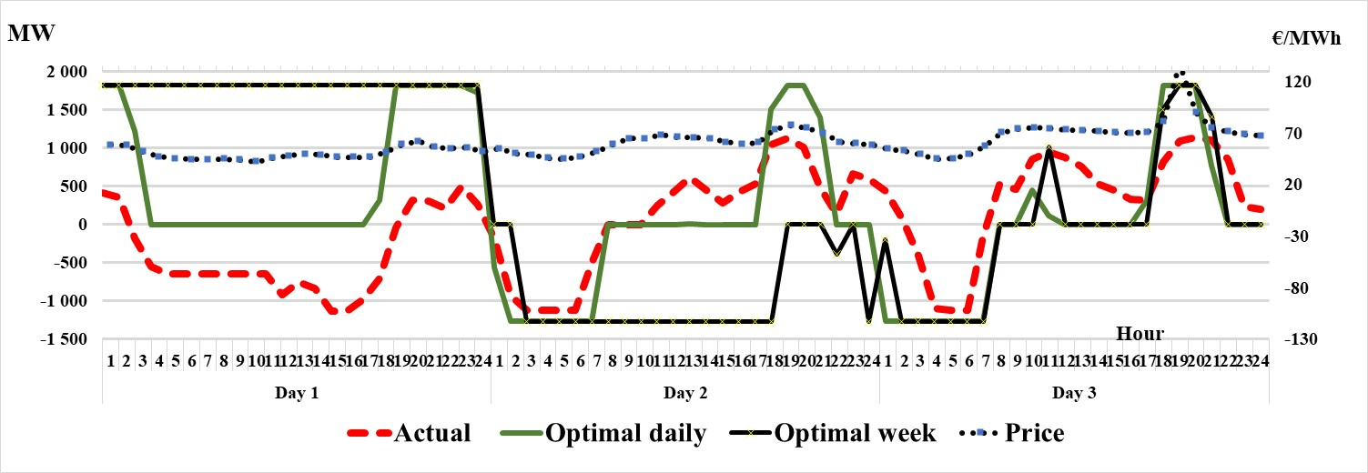
Fig 1. Actual versus Optimal operation of Grand’maison PHS plant over three days
Over the year, the graphical representation of the effective operation of the PHS Grand’maison plant is not constant, as the match between the historical behaviour in 2017 and the optimisation seems to alternate the weekly storage with the daily storage on an irregular basis. This partly confirms that the economic model of the PHS plant is not driven by the spot market only, but it simply correlates with (75% over the year). Hence other strategic options have been contemplated, mainly driven by the system operator by means of some contractual arrangements with other power plants. At a glance, the gap actual-optimal operations reveals the provision of a service close to ramping energy blocks such as defined in Cigre report (2019) as being specific to systems exposed to high ramping. Corollary, four large nuclear power plants are located in the proximity of Grand’maison PHS plant and despite their commitment to meet a forecasted load profile, the anticipation of the rate of change is constantly subject to technological constraints of efficiency and safety. All french nuclear power plants are capable of load-following and they all provide flexibility and ancillary services to the grid. However, in case of requirements for faster response and longer lasting reserve, negative reserve in particular, operations could be limited by the reactor design in terms of ramping and minimum load safety requirements. PHS storage could be integrated within the nuclear facility, and naturally form a single entity as their both belong to the EdF operator. The study will give the optimal share of the PHS support to the nuclear plant(s) by analysing the dispatch of all generators in the French energy mix, such as to set the residual time the PHS operator could bid on the day-ahead and infraday segments as a stand-alone market player.

Conclusions
The absence of a clear role of the energy storage, as a weekly or daily storage, as a stand-alone market player or a service provider, indicates that the decision to invest into new PHS facilities keeps being integrated into a broad central energy planning strategy. In a context where the French power system evolves towards longer and faster system services, the regulator needs rethinking the role of both energy storage and generators in providing ancillary services (Tang et al, 2018). In particular, nuclear power plants need clear signals on the adjustment speed necessary to follow the load which becomes more variable with the massive entry of wind and solar power, while energy storage needs clarification on the complementary or substituting role it will play in future scenarios. Two simple contractual options could be foreseen, one concerning the share of ancillary services the storage should provide such as to optimaly use the remaining capacity on the spot market; and the other one identifying the beneficiary of the service support such as to regularly legitimate some forms of vertical integration, e.g. with the TSO or with generators such as renewable plants and the nuclear power fleet. As the mangement of the PHS plants seems to be decentralized with some plants pumping and other discharging at the same time, contracts need clarification on a case by case basis. Ultimately, the general public needs understanding the strategic value of the asset such as to locally accept building new PHS projects and to financially support the high investment costs.

References
CIGRE, 2019. Regulation and market design barriers preventing to capture all the value
from fast and high-location-freedom energy storage. Report Reference 752.
EdF, Ursat X, Jacquet-Francillon H, Rafaï I, 2011, Experience of EDF in the field of pumped-storage power plants
Gaudard L, Madani K. 2019. Energy storage race: Has the monopoly of pumped-storage in Europe come to an end?, Energy Policy126: 22-29.
PPE, 2018, La Programmation Pluriannuelle de l’Energie.
Teng F, Pudjianto D, Aunedi M, Strbac G. 2018. Assessment of future whole-system value of large-scale
pumped storage plants in Europe, Energies 11.

RTE, 2017, http://clients.rte-france.com/lang/fr/visiteurs/vie/prod/production_groupe.jsp, accessed at 03/11/2019.

