Overview

Second Degree Price Discrimination in Retail Gasoline Markets

Travis Roach, University of Central Oklahoma, (405) 974-2934, troach2@uco.edu

The Federal Renewable Fuel Standard has had myriad unintended consequences. Among them, is the ability for retail gasoline firms to offer differentiated fuel products from the same location and express market power. Evidence of this can be seen in the array of ethanol products from the much-maligned E85 (an 85% ethanol blend), to the widely accepted E10, to conventional gasoline (E0). This study uses the latter two grades of fuel, E10 and conventional gasoline, to study how firms are using prices to coordinate consumption of these fuels. This practice is known as second degree price discrimination.

Second degree price discrimination is a pricing strategy that firms may use in order to extract more profit per consumer. Firms use second degree price discrimination when they have no identifiable traits from their consumers that they can use to determine whether or not they highly value a product or service; for example senior discounts or student pricing. In order to raise profits, then, firms use a variety of product qualities and pricing options to intice individuals to consume their “appropriate” package, for example first class and business class seating on flights.

Empirical evidence of second degree price discrimination remains somewhat of an enigma in the economics literature. This is due to a multitude of confounding factors including endogeneity of menu choices and product differentiation across multiples horizons (e.g. vertical, horizontal, or spatial differentiation). The co-existence of 10% ethanol-blended (E10) gasoline and regular (E0) gasoline in a major metropolitan city, however, allows for second degree price discrimination to be examined while eliminating the issues of endogenous product differentiation because the two blends of gasoline are near-perfect substitutes. Using a unique data set including daily price information for over 400 retailers that sell regular gasoline only, ethanol-blended gasoline only, or both blends simultaneously, I find evidence that retailers use second degree price discrimination to segment the population between perceived lower and higher quality gasoline; despite the fact that both blends can safely be used in nearly all vehicles.

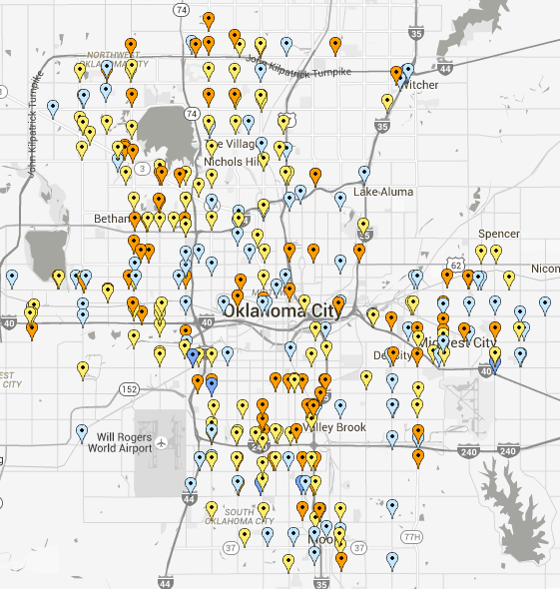
Methods
I uncover evidence of second degree price discrimination using an embeded difference-in-differences framework in a structural model of gasoline supply. The structural model is based on an asymertic vector-error-correction model. The daily data for this study cover 402 retail gasoline stations over four months in the Oklahoma City metropolitan area. Stations that sell E10 only comprise 35.1% of the sample (yellow), regular gasoline only stations makes up 34.7% (blue), and stations sell both grades simultaneously make up 30.2% of the sample (orange). Figure 1, to the right, shows the distribution of station types acorss the city. As a robustness measure I compare the price on diesel for stations that sell both types of fuel with the sations that sell only E10 or regular. I do not find evidence that stations that sell both grades also have a higher premium for diesel grade fuel. This shows that market power is limited to firms being able to offer differentiated fuel types.

Results

Firms that offer both types of fuel are able to exert market power and segment their customer base using prices as a coordinating mechanism. The average price differential between the two types of fuel at stations that sell both E10 and regular simultaneously is $0.111 after controlling for differences in wholesale costs. This compares to an average differential between the two types of fuel (at single-type stations) of $0.13. Thus, firms that sell both fuel types find it optimal to price discriminate even though there is local competition for both fuel types from single-type stations.

On an energy efficiency adjusted basis, while holding RIN price movements constant, the fuel efficiency adjusted price differential should be 5.8 cents on average. This shows that the mere existence of both fuel types allows for firms that sell regular (E0) gasoline to charge an 8 cent premium for single-type stations (beyond wholesale cost differences), and a 5 cent premium at stations that sell both types. Even after accounting for RIN price changes I find that stations that sell regular grade are able to exert market power and charge a higher premium.

Using the structural estimates I am also able to uncover two separate elasticities of demand for gasoline and discuss the welfare effects of price changes and market segmentation. Unsurprisingly, the elasticity of demand for regular gasoline is higher than that for E10 gasoline.

Conclusions

The dual existence of ethanol-blended and non-ethanol blended gasoline leads to very interesting price dynamics for both grades of fuel. Even though the two products are near-perfect substitutes, non-ethanol blended gasoline consistently has a higher markup than ethanol-blended gasoline. Interestingly, this difference is more drastic at stations that sell both types simultaneously.

The impacts of this pricing behaviour are wide ranging - especially when one considers the amount of disposable income that is allocated to fuel expenditures. One example can be seen in the difference in yearly expenditures between the two types of fuel. Assuming rather conservative fuel consumption patterns I find that consumers that choose to purchase non-ethanol gasoline spend $164 more per year. Even after adjusting for differences in energy efficiency these consumers spend nearly $130 more per year in markups alone.

Ethanol is 33.3% less efficient than regular gasoline. Thus, E10 is 3.33% less efficient. One should be indifferent between the two types of fuel if regular gasoline is 3.33% more expensive than E10.

