HOW MUCH IS ENOUGH? EU-ETS INDUCED NATIONAL CLIMATE TARGET UNCERTAINTY

Michael Pahle, Potsdam Institute for Climate Impact Research (PIK), Phone +49 331 288 2465,
E-mail: michael.pahle@pik-potsdam.de
Paul Nahmmacher, Potsdam Institute for Climate Impact Research (PIK), Phone +49 331 288 2465,
E-mail: paulnah@pik-potsdam.de
Christian Flachsland, Mercator Research Institute on Global Commons and Climate Change (MCC),
Phone: +49 30 338 553 7246, E-Mail: flachsland@mcc-berlin.net

Overview
While current EU-ETS prices are at a persistently low level, they are expected to rise in the future if the currently envisaged long-term targets and the ambitious linear reduction factor (LRF) of 2.2% annually from 2020 are maintained. Importantly however, it is unclear when exactly prices will rise again and to which level. First of all, is not yet clear if the MSR will have an effect on prices at all. It is also not clear if the LRF – the legal status of which is only indicative for the period post-2030 – will be maintained or changed again. Moreover, further regulatory measures and reforms to correct prices might be taken in the future, and it also not yet clear how the overall target is distributed between ETS and non-ETS sectors (to be decided in 2016). In addition, prices are also influenced by a number of other factors including for example economic development. Hence all projections for future EU–ETS price trajectories are speculations at best, and from the point of decision makers they constitute a deep uncertainty with unknown prior probabilities.
This leads to considerable challenges for investors and policy-makers alike. While the scientific literature typically focusses on the former, the problem of the latter is specific and arises from the EU’s multi-level design. From a member state level perspective the EU-ETS “turns” from a quantity instrument to a price instrument beyond national policy makers’ direct control. In consequence, if there are national GHG targets then national policymakers cannot ensure that these will be met. Such targets for example exist in France (2030/2050), the UK (2050), Germany (2020/2030/2040/2050) and also other member states. If these countries want to ensure attainment of their national targets, they have to take additional measures contingent on the (uncertain) extent of the eventual GHG emission reductions induced by the EU-ETS. Apparently, the main challenge is to know in advance how large the “gap” will be, and which measures will be needed in which sectors in particular in some sort of worst case.
Against this background, we analyse the case of Germany. There has been a discussion about its attainment of year 2020 GHG target (at least -40% relative to 1990) for some years, in the course of which different measures were discussed. The political turmoil this has created underlines the need to plan well in advance, which is why we analyse the domestic 2030 GHG target (-55% relative to 1990 or 562 Mt compared to 2012 levels). Using different scenarios of uncertain factors, in particular the EU-ETS prices but also other factors like fuel prices and demand, we assess the range of domestic emission reductions through the ETS and national instruments in place (EEG), and consider options for closing potentially occurring gaps between outcomes and targets.

Methods
We use the EU long-term power market model LIMES-EU (Nahmmacher et al. 2014) to compute future GHG emissions in the German power sector under different scenarios defined by combinations of possible future states of all relevant uncertain factors: ETS prices, the price spread between hard coal and gas, and power demand. Altogether we analyse 30 (5x2x3) scenarios, whereby in line with the focus of this work special emphasis is put on future ETS prices by assuming five different trajectories shown in Figure 1 based on the range found in the most recent literature. The broad range of prices for 2030 and beyond further underlines the considerable uncertainty.
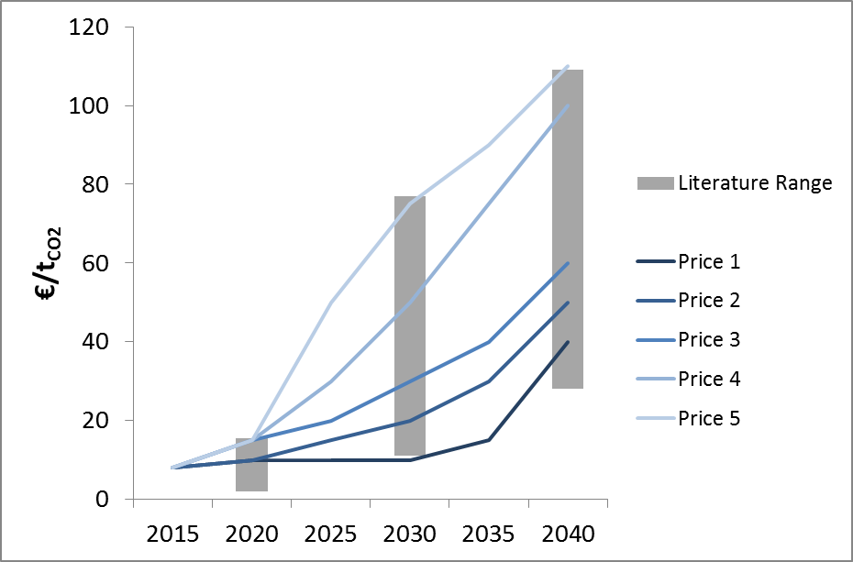
Figure 1: ETS price trajectory assumptions
To increase accuracy of the model, we further implement complementary national polices in the model. In particular we take account of the recently updated annual renewable expansion targets and the panned phase out of older coal plants (“Klimareserve”) decreed last year.

Results
Preliminary results so far (Figure 2) show that GHG emission in 2030 can vary considerably. Compared to current levels (2012: 326 Mt), the range defined through the extreme cases varies from only a marginal reduction (~300 Mt) to a de-facto decarbonization of the power sector (~25 Mt). It turns out that increasing demand (+10%) and lowest ETS prices (10€/t) lead to lowest reductions more or less irrespective of the coal-gas spread. In contrast, a low coal-gas spread can significantly reduce emission in case demand is lower (-10%) and ETS prices are highest (75€/t). Most interestingly, in this case coal would be phased out completely until 2030.
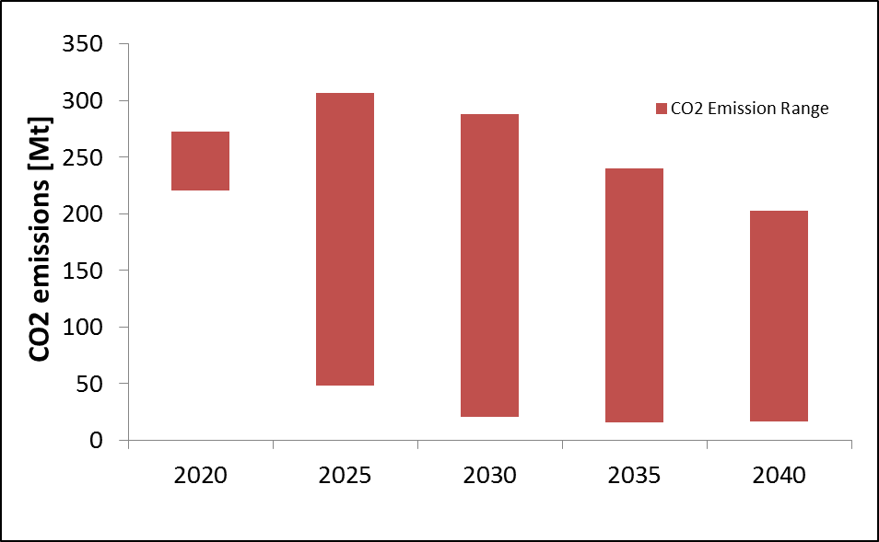
Figure 2: CO₂ emissions range

Conclusions

The enormous range of possible GHG emission in the German power sector in 2030 raises the question of domestic policy design under uncertainty. In the case of very high reductions resulting from combined internal policies and external factors, Germany might overachieve on its overall GHG target, or opt to relax the stringency of domestic climate policies (within and outside the power sector). In the case of very low reductions resulting from domestic policies and external factors, either the stringency of domestic power sector policies needs to be increased or higher GHG reductions are necessary in other. The latter option would be very challenging not only in view of these sectors partly being regulated via (sometimes uncertain) EU policies as well, but due to the low projected GHG reduction in policy as usual scenarios and the significant scale and short time available to implement additional reductions to make up for a shortfall in power sector abatement. Accordingly, policy makers should take action early on if they want to avoid to rely on yet another messy quick fix in the next decade.

References
Nahmmacher, P., Schmid, E., Knopf, B. (2014): Documentation of LIMES-EU - A long-term electricity system model for Europe. Available at: https://www.pik-potsdam.de/members/paulnah/limes-eu-documentation-2014.pdf

See national factsheets for the state of the EU Energy Union: http://ec.europa.eu/priorities/energy-union/state-energy-union/index_en.htm

