Overview

Improved Experience Curve Indicates Large Future Cost Reductions for Wind Power

Ryan Williams, Rochester Institute of Technology, 315-719-4595, rw8719@rit.edu
Eric Hittinger, Rochester Institute of Technology, 585-475-5312, eshgpt@rit.edu
Eric Williams, Rochester Institute of Technology, 585-575-7211, exwgis@rit.edu

The potential for future cost reductions in wind power is an important question. Prior analyses of past cost reductions give contradictory results, with learning rates (fractional cost reduction per doubling of cumulative production) ranging from -3 to 32% (Azevedo et al 2014). This lack of consensus has, we believe, contributed to conservative forecasts of cost reductions of wind power. The Annual Energy Outlook of the Energy Information Administration assumes wind costs fall at the same rate (minimum 5% by 2035) as coal power (EIA, 2014). The recent Department of Energy wind report uses a range of 0-10% for its offshore learning rates with 5% as the base case and is even more cynical on land based wind (DOE, 2015). In this work we analyze sources of variability in modeling cost reductions and develop an improved method that reduces variability. Our method is based on a single factor experience curve that accounts for capacity factor gains, wind quality decline, and exogenous shifts in capital costs. With this improved methodology, the wind learning rate range is found to be 10-21%, with the best estimate at 16%. Using DOE estimates of wind deployment, the cost of wind power will decline from a current price of 5.4 cents/kWh to 3 cents/kWh in 2030, significantly lower than the DOE assumption of 4 cents/kWh in 2030. At these prices, unsubsidized wind can compete favorably with natural gas, coal, or nuclear power, suggesting that greater support and investment in wind should be strongly encouraged.

Methods
Forecasting technological progress is often done through experience curves and learning rates. The experience curve is the observed power law decline of unit cost as a function of cumulative production. The single factor experience curve takes the form: C = C₀ (P/P₀)^{-α} , where C is the price per unit, P is the unit produced, C₀ and P₀ are the initial cost and production values, and α is the learning coefficient. The learning coefficient α is used to find the cost reduction for each doubling of cumulative output. This also called the learning rate (LR) expressed in terms of alpha by LR = 1-2^{-α} . While two or more factor models can help identify specific drivers of progress, the single factor learning curve estimates a technology's general progress and can estimate future price with fewer input parameters, such as research development investments. Despite its simplicity, Equation (1) fits empirical data surprisingly well. Nagy et al (2013) showed that R-squared exceeds 90% for a majority of 62 technologies.
A recent literature review of energy technology learning rates found that there is large variation in the range of reported rates (Azevedo et al, 2014). This was especially true of wind learning rate estimates, with learning rates ranging from -3% to 32%. This range lack of agreement could lead some to believe that the learning rate is a poor indicator of wind's progress. We argue that it is too early to dismiss the experience curve for wind and explore modifications of the model structure. The empirical robustness of different model choice is studed, including sensitivity to start and ending years of the data set. We develop the curve for wind power development in the United States.

Results

Figure 1 compares four variants of the experience curve. The first model is typically used in the literature, linking capacity cost ($/W) and cumulative capacity (MW). The second model switches the production unit to generation (kWh) as opposed to nameplate capacity (W). The third model accounts for generation but also adjusts for annual variations in wind and declining wind quality of developed sites. The fourth model improves upon the third by correcting for fluctuations in investment costs exogenous to the wind sector.
The empirical robustness of the model improves along with the model modifications. What we find more compelling than higher R-squared is reduced sensitivity to the starting and end years of the data set. Nearly all the variability in prior learning rate results can be explained by different time ranges of the dataset. For the U.S. dataset, the traditional experience curve for capacity gives learning rates from -6%-28% depending on starting and end years. The modified model accounting for generation, wind variability and exogenous capital fluctuations has learning rates from 10-20% depending on starting and end years.

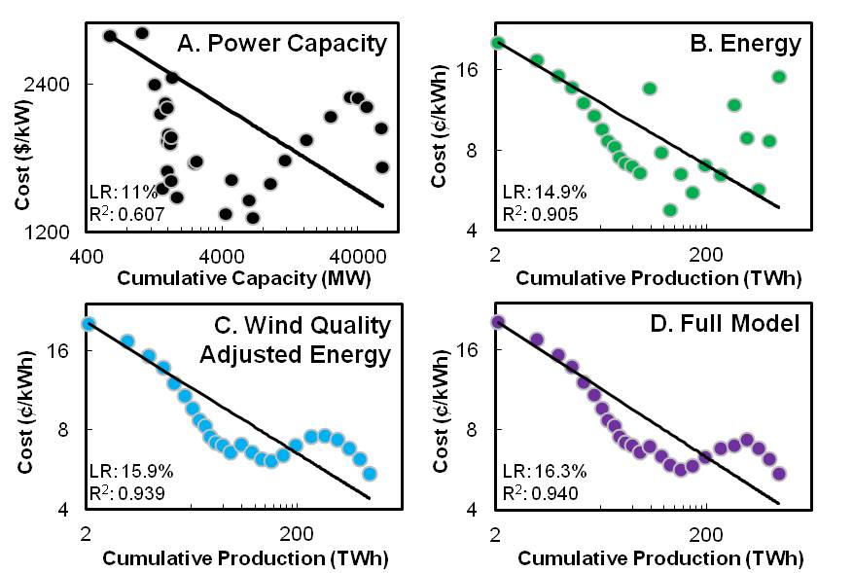

Figure 1. Experience Curves for wind power costs in four different models, in log-log scale, with learning rate (LR) and R² value reported. The Power Capacity Model (A) model uses installed power generation capacity (kW) as the independent variable, the approach used by most previous researchers. Energy Model (B) uses energy generated (kWh) instead of power (kW) as the independent variable. The statistical fit improves because installed power does not account for improvements in capacity factor. The Wind Quality Adjusted Energy Model (C) differs from (B) by adjusting capacity factors to correct for annual weather-based variability in wind and changes in wind quality at installed sites. Finally, the Full Model (D) graph adds adjustments to (C) for exogenous fluctuations in capital cost. Model (D) thus accounts for capacity factor improvements and separates out technological progress from exogenous variability in wind quality and capital costs.

Conclusions

Confusion about how to measure the learning rates for wind power has contributed to conservative forecasting with pessimistic outlooks for future costs. Applying a 16% learning rate to the DOE's estimates of wind deployment to 2030 indicates that wind power can be expected to decrease in cost from 5.4 cents per kWh to 3 cents per kWh in the next 15 years. This will make wind cheaper than coal or natural gas generation, even without subsidies or carbon prices. While occasionally considered a mature technology, wind generation has more to gain and is a more viable energy source than we have been lead to believe.

References
Azevedo, I., Jaramillo, P., Rubin, E., Yeh, S., 2013. Model Technology Learning for Electricity Supply Technologies. Electric Power Research Institute, Palo Alto, California.
EIA, 2014. Annual Energy Outlook 2014. U.S. Department of Energy, Energy Information Administration.
DOE, 2015. Wind Vision: A New Era for Wind Power in the United States. Department of Energy, Wind and Water Power Technologies Office.
Nagy B., Farmer J.D., Bui Q.M., Trancik, JE., 2013. Statistical Basis for Predicting Technological Progress. PLoS ONE 8(2): e52669.

