Assessment of Fuel Switching on Vehicle Emissions Using Tunnel Data

WT Hung, Department of Civil and Structural Engineering, The Hong Kong Polytechnic University, cewthung@polyu.edu.hk
Ricky KL Mak, Department of Civil and Structural Engineering, The Hong Kong Polytechnic University, ce.ricky@polyu.edu.hk

Overview
Hong Kong Government has implemented a billion dollars worth fuel switching programme to improve the air quality especially in the urban areas of Hong Kong starting from 2000. This programme includes introduction of ultra low diesel, liquefied petroleum taxis, hybrid vehicles and Euro standard for new registered vehicles. According to the air monitoring data at the roadside, the changes in pollutant concentrations are not conclusive although cleaner fuels should theoretically produce fewer pollutants. There is a need to prove to the community that the fuel switching programme is effective in reducing vehicle exhaust pollutants. This study employs the air pollutant monitoring data at a popular tunnel from 2001 to 2006 to estimate the change in emission factors for various types of vehicles.

Methods
Simple mass balanced model (SMBM) and speed modified mass balanced model (SMMBM) are applied to estimate the emission factors for three classes of vehicles (small, medium and large sized vehicles) with different fuel types, i.e., LPG, petrol and ultra low diesel over the year 2001 to 2006. Changes in aggregate and disaggregate emission factors over time are then discussed and causes for such changes are explored.

Results
Figure 1 demonstrates the change in aggregate CO emission factor over the years after switching vehicle fuels to cleaner versions. A typical regression line is drawn to demonstrate the linear relationship. The coefficient of determination, R² of over 0.6 indicates a distinct downward trend.

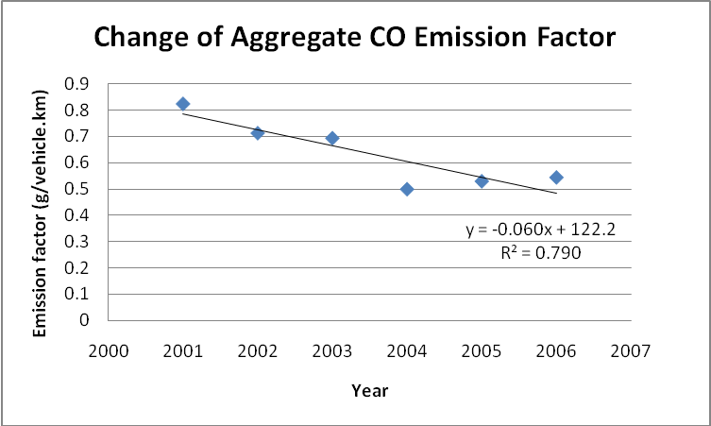
Figure 1: Change of aggregate CO emission factor over the fuel switching period

Conclusions
The fuel switching programme in Hong Kong is effective in reducing emissions from vehicles, as estimated from air quality monitoring data at a popular road tunnel. The results of CO and NO aggregate emission factors estimation over the year 2001 to 2006 demonstrate overall reduction trends in both gaseous emissions; with a sharper reduction in CO (6% per annum) but milder reduction in NO (0.7% per annum). Closer examination of the trends show the CO was reduced at a faster rate in the first four years but slightly increased in the last two years. NO was increased slightly in the first four years but reduced at a faster rate in the last two years.The roadside air pollutant concentrations do not show similar discernable trends, probably because of other factors such as the street configuration and the building density.

