Overview

Future Costs of Global Gas Supply – A model-based Calculation
Stefan Lochner *
Institute of Energy Economics (EWI)
at the University of Cologne
Tel. +49-221-17091814
Stefan.Lochner @uni-koeln.de

Dr. David Bothe
Frontier Economics Limited
Tel. +49-221-33713106
David.Bothe@frontier-economics.com
Quickly declining natural gas reserves in some parts of the world, increasing demand in today’s major gas consumption regions in Europe, the U.S. and the Far East, the emergence of new demand centres such as India and China and the globalization of natural gas markets caused by the rising importance of Liquefied Natural Gas (LNG) are changing global gas supply structures and will continue to do so over the next decades. Based on our own reference forecast for global gas supply up to 2030, which is briefly presented in the context of the results, we calculate the long-run average costs of gas supplied to the world’s major consumption regions for the different suppliers of these regions in the year 2020. These include capital as well as operating costs for production and the relevant mean of transport to the consumption market, i.e. pipeline transmission and/or LNG. Results for the different consumption markets are compared and analysed with a focus on supply costs and the different roles of LNG across markets.

Methods
We apply EWI’s global gas supply model MAGELAN to simulate world-wide developments in the gas market up to 2030. The linear cost-minimization model MAGELAN takes into account all major existing capacities on the production and transport side and the relevant cost parameters as well as data on reserves. MAGELAN’s extensive database contains all those information and aggregates them to 139 nodes and more than 400 pipeline and LNG connections in order to represent the global gas market. The model is then capable of endogenously adding new transmission pipelines, LNG terminals and production facilities to cost-optimally satisfy a given demand. Based on these results, capital investments are determined and allocated to the corresponding gas flows via annuities assuming a full utilization of assets. Adding the respective operational costs, which are expected to decline from today’s values with individual technological progress factors, yields the long-run average costs of gas supply from each production region to each consumption market.

Results
Deriving natural gas supply cost curves for the investigated consumption regions based on our supply projections allows comparing them with respect to supply diversification and supply costs (see Figure 1).
For Europe (including Turkey), our model projects the least-cost supply of natural gas from a non-European country to come by pipeline from Iran which provides about 50 billion cubic meters in 2020. The LNG supplier with the lowest costs is projected to be the United Arab Emirates which, like Qatar, will deliver relatively small quantities of LNG, mainly to Northwestern Europe. Europe’s largest foreign supplier continues to be Russia with exports to Europe totalling almost 300 billion cubic meters in 2020. These volumes can be delivered at a marginal cost of 1.86 US-$/MBTU (real 2005 US-$) via new and existing pipelines in the transit countries and the Black and the Baltic Seas. Norway will also be able to supply significant volumes (125 billion cubic meters) at costs below 2.00 US-$/MBTU. With only slightly higher costs, the central Asian country of Kazachstan will be the marginal supplier of gas to Europe with costs of 2.15 US-$/MBTU. These figures show that natural gas to Europe in 2020 will mainly be supplied via pipeline. Compared to its rising global importance, LNG will only play a minor role in Europe.
In the United States, only roughly 50 percent of natural gas will be supplied by pipeline from the Gulf, the mainland U.S. and Canada (this includes natural gas from Alaska swapped with Canadian gas). These volumes can be supplied at costs below 1.75 US-$/MBTU. The remaining 350 billion cubic meters the country requires according to the underlying demand assumption will have to be provided as LNG. However, at 2.25 US-$/MBTU, even the least-cost LNG supplier Algeria incurs higher costs supplying the U.S. than the marginal supplier in Europe. In the range up to 3.00 US-$/MBTU, 270 billion cubic meters per year can be provided by a number of countries in Latin America, Africa and the Middle East, the largest of them being Trinidad & Tobago, Nigeria, Qatar and Venezuela. According to our projection, in 2020, the residual 44 billion cubic meters of naturals gas will be supplied at marginal costs in excess of 3.00 US-$/MBTU by Egypt, Angola, Peru and Norway. With costs of 3.34 US-$/MBTU, Norway will be the marginal supplier to the United States in 2020.
Figure 1: Gas Supply Cost Curve Europe (incl. Turkey) (left) vs. USA (right hand chart) in 2020
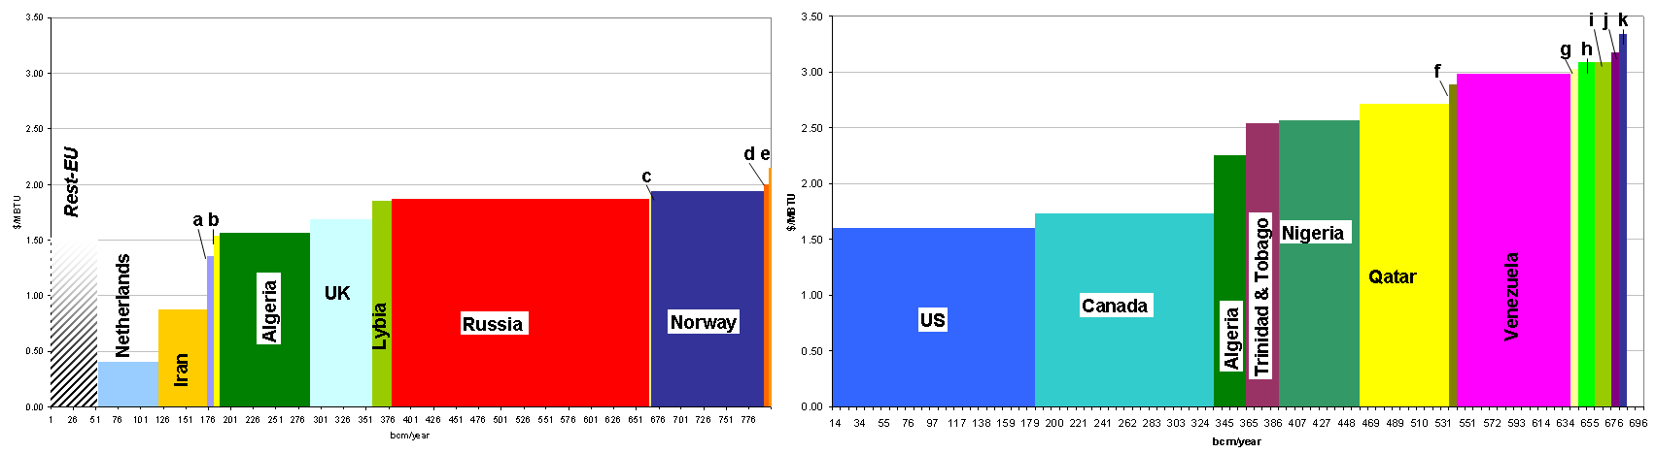
left: Rest EU = EU-27 without UK, Netherlands, Denmark; (a) Denmark, (b) Arab Emirates, (c) Qatar, (d) Azerbajian, (e) Kazachstan
right: (f) Equatorial Guinea, (g) Yemen, (h) Egypt, (i) Angola, (j) Peru, (k) Norway

Comparing the two downstream markets shows that the costs of gas supply differs significantly. For Europe, 99 percent of demand can be supplied at costs below 2.00 US-$/MBTU, mainly by pipeline. In the United States, declining gas reserves in production regions connected by pipeline require significant investments in gas supply infrastructure, not only in LNG import terminals in the U.S. but also in liquefaction capacity upstream. This drives up long-run average costs of gas supply for all U.S. LNG imports (which provide more than 50 percent of total consumption). The supply costs of the United States’ marginal gas supplier, Norway, are more than 55 percent higher than for Europe’s marginal supplier from Central Asia.

Conclusions
The costs of the marginal gas supplied will differ greatly between the world’s consumption markets according to our projections. We find that while Europe’s gas imports will be less diversified, gas can generally be delivered at lower costs. This is due to its favourable location close to a number of countries with significant gas reserves which are able to supply gas by pipeline at low costs on partially already fully depreciated existing routes. For the same reason, LNG will only play a minor role in Europe in comparison to other markets. In the United States, more than 50 percent of gas supply will be delivered as LNG by 2020. This imputes significantly higher costs but also allows a higher degree of supply diversification by choosing among an increasing number of LNG exporting countries. Moving from supply costs to actual prices, this implies that LNG and therefore gas prices in the Atlantic and Pacific Basins are going to be set in North America. For Europeans to actually obtain LNG, they will have to pay a significant premium on actual supply costs making it by far the most expensive source of natural gas.

References
Bothe, David/ Lochner, Stefan (2008): ”Die ewiGAS₂₀₀₈ Prognose“, In: Zeitschrift für Energiewirtschaft, Vol. 32(1), pp. 22-29.
IEA (2006): World Energy Outlook 2006. Organization for Economic Cooperation and Development/ International Energy Agency, Paris.
Jensen, James T. (2004): The Development of a Global LNG Market – Is it likely? If so when? Oxford Institute for Energy Studies, Oxford.
Seeliger, Andreas (2006): Entwicklung des weltweiten Erdgasangebots bis 2030. Schriften des Energiewirtschaftlichen Instituts, Bd. 61, München.
WEC (2007): 2007 Survey of Energy Resources. World Energy Council, London.

* Corresponding author. Address: Albertus-Magnus-Platz, 50923 Cologne, Germany. Internet: http://www.ewi.uni-koeln.de ? See Seeliger (2006).
In this case we refer to IEA (2006) for demand projections.
Gas supplied by European countries with small domestic gas production (around 53 billion cubic meters in total in 2020) is summarized as Rest-EU supply in Figure 1. This production is exogenous to the model. Its position in the supply curve is less important as these countries (i.e. EU-27 without UK, Netherlands, Denmark) do not export to non-European countries.

