MODELING OF THE INTERACTIONS BETWEEN SECTORAL CO₂ EMISSIONS AND ENERGY EFFICIENY UNDER EMISSION RESTRICTION POLICIES
Kemal Sarıca, Nihan Karali¹

¹ Department of Industrial Engineering, Boğaziçi University, 34 342, Bebek, Istanbul, Turkey

Overview
The purpose of this study is to understand the dynamic effects of carbon dioxide (CO2) emission restrictions and energy price policies on two highly energy intensive sectors of industry; iron&steel industry and cement industry over a 12 year period. Model is designed so that critical decisions such as growth and efficiency investments are based upon profit and extra costs incurred due to CO2 emissions. The profit margin, CO2 cost over revenue and Energy Cost Share in Total Annual Production are important key variables in the model.
This study, giving attention to the economic and energy-emission policy aspects, aims to analyze the causal relationships and the feedback structures among industry’s production capacity, investments on new and energy efficient technologies, financial burden, and CO2 emissions.

Methdos
Model design and construction is based upon following principles and assumptions:
Model is designed so that critical decisions such as growth and efficiency investments are based upon profit and extra costs incurred due to CO2 emissions. The profit margin, CO2 cost over revenue and Energy Cost Share in Total Annual Production are important key variables in the model.
Model horizon is kept short since our main objective is to cover possible responses of energy intensive sectors in Turkey in near 10-12 year horizon with possible policy implementations such as energy prices, emission restriction levels and CER/VER (Certified Emission Reduction / Verified Emission Reduction) Prices. Also short time horizon includes some advantages such as possible model simplifications. This may become important in the long run such as emission factor of energy used by the sector which is currently determined by historical data and possible future trends.
Figure 1 displays the self reinforcing growth loop of a general sector. As new capacity is added to Production capacity, Annual Production increases. Increase in annual production leads to more revenue and more profit. Increase in profit leads higher growth rate and more New Capacity addition. This loop is the main driving power of a sector without CO2 and energy price effects.

Figure 1 Main Growth Loop of the model
Figure 2 displays the self balancing loop of CO2 emission and efficiency improvement loop. As the energy consumption per unit production increases Annual energy consumption increases leading to higher Total CO2 Emission. This increase in Total CO2 emission levels increases average annual CO2 emission that pushes the current deviation level from base year emissions to higher levels (Target Deviation from Base year CO2 Level). Thus reduction cost of CO2 emissions by purchasing CER/VER certificates becomes more costly. This leads to investment on efficiency improvements due to CO2 emission which decreases efficiency index values. This decrease, with a delay, will decrease the average efficiency index value thus reducing Energy Consumption per unit production.
Figure 2 CO2 Emission - Efficiency Improvement Loop

Figure 3 shows two loops. First loop is Production - CO2 emission interaction balancing loop. Increase in Production Capacity leads to higher Annual Production. This increases annual energy consumption which directly increases average annual CO2 emission. This leads to higher deviation from the base year CO2 level. Therefore CO2 Cost decreases profit of the sector. Low profit level decreases growth rate, growth rate decreases Production capacities. Lower Production capacity decreases Annual Production.

Second loop is Production – Energy Price interaction self reinforcing loop. Increase in annual production cost leads to higher energy cost in annual production cost, thus increases energy cost share in total production cost. This trigger increases the investment on efficiency due to energy prices. Energy efficiency index decreases due to investments. With a delay average efficiency index value decreases leading to decrease in annual energy consumption. With same interactions of the first loop after Annual energy consumption, Annual Production increases.

Exogenous variables are obtained analyzing the past six-year data of each sector. Energy prices and emission factors are the weighted average of sector specific primary energy resource prices and emissions, respectively.
Figure 3 Production - CO2 emission and Production - Energy Price Interaction loops

Results
Base Case Scenario:
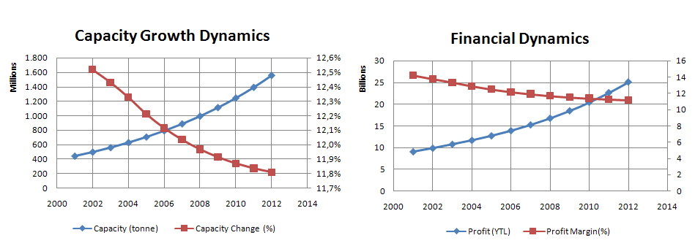
Figure 4 Capacity Growth and Financial Dynamics of Base Scenario for Steel Sector

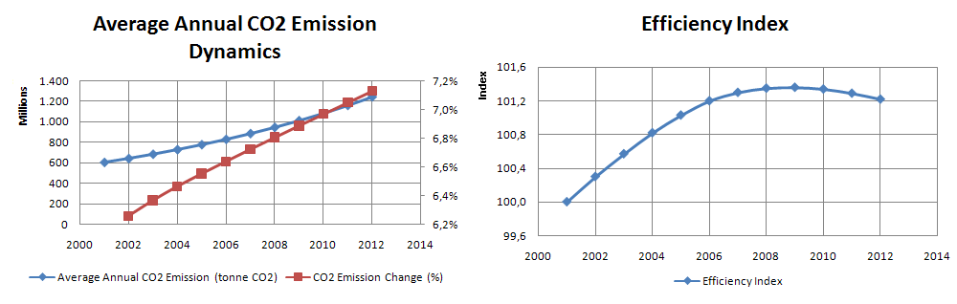
Figure 5 CO2 Emission and Efficiency Index Dynamics

CONCLUSION
This study analyzes the economical and energy-emission related policy aspects of the industrial sector of Turkey; and aims to analyze the causal relationships and the feedback structures among industry’s production capacity, investments on new and energy efficient technologies, financial burden, and CO₂ emissions. The model takes efficiency improvement into consideration. The interactions between the CO2 emissions and efficient technology investment depend on the price of energy and CO2 emission payment (CER/VER prices). In addition to a Base Case Scenario, two energy-emission related scenarios are defined restricting CO₂ emissions under higher CER/VER and energy price trajectories.
The model simulation shows that in any case it is not possible to achieve the target emission levels (8% below the base year levels). For steel case, the most influential factor on CO2 emission reduction is found as CER/VER price. Energy price follows it as the second driver factor. CO2 emission restriction level does not have a comparable impact on CO2 emissions as much as energy price and CER/VER prices do. Profit margin decay rate is mainly dependent on CER/VER price changes. Restriction level changes create significant biases but the pattern stays unchanged.

Corresponding author. Tel.: +90-212-3597072; fax: +90-212-2651800. E-mail addresses: saricake@boun.edu.tr ; nihan.karali@boun.edu.tr

