Deriving Cost-Resource Curves for Wind-Onshore energy in the EU using a Geographical Information System
Anne Held*, Heike Krause°, Mario Ragwitz*
*Fraunhofer-Institute for Systems and Innovation Research,
Breslauer Straße 48, 76139 Karlsruhe, Germany
Phone: +49-721-6809-358
Fax: +49-721-6809-272
E-mail: anne.held@isi.fhg.de; mario.ragwitz@isi.fhg.de
°Landesanstalt für Umwelt, Messungen und Naturschutz Baden-Württemberg,
Bannwaldallee 24, 76185 Karlsruhe, Germany
Phone: +49-721-5600-1302
Fax: +49-721-5600-1515
E-mail: heike.krause@lubw.bwl.de

Overview
The use of wind onshore energy might contribute significantly to climate protection and reduces European import dependency in the electricity sector. At the end of 2007, wind based electricity production already amounted to 98 TWh in the EU (EurObserver, 2008). In order to quantify the feasible contribution of wind onshore energy in the future, the existing potential throughout Europe is defined within this analysis. Since electricity generation costs of wind energy depend largely on local wind regimes, not only the overall potential but also the corresponding costs of electricity generation have to be considered. Therefore, this analysis derives detailed cost-resource curves for wind onshore energy in the EU on a regional level.

Method
The derivation of the wind onshore cost-potential curves is based on a geographical information system. First, regional wind velocities are transformed into full load hours (ratio between nominal capacity and annual electricity output). In a second step the available area for the construction of wind-turbines is estimated. Finally, both results are combined in order to determine the feasible electricity output in each region.
For the calculation of the full-load hours, a wind speed dataset created by the Climate Research Unit is used (New et al. 2002). Wind speed data are given for a height of approximately 10 m on a geographical resolution of 10' * 10'. As wind speed varies depending on the altitude, the wind speed is corrected to turbine height, which is assumed to be at 80 m within this study. We assume neutral atmospheric stability conditions and calculated the adapted wind speed according to the barometric formula. The real power output of a wind turbine is determined by turbine characteristics and the local wind regime. Regarding the wind regime, the power output is not only a function of the average wind speed, but rather follows a probability distribution, or more precisely the Weibull distribution. However, due to missing data concerning the wind speed distribution on a highly disaggregated time resolution, the relation between wind speed and power output was approximated by using a linear relation based on theoretical power curves for a certain wind speed interval. As reference turbine, a 2 MW turbine of Vestas was selected (Vestas V80).
The estimation of the available area for the construction of wind turbines is based on the CORINE land-cover database created by the European Environmental Agency (EEA). Existing constraints are considered and used for a reduction of the suitable areas for wind turbines. The first step is the exclusion of naturally protected areas (WDPA Consortium, 2006). Then urban areas are removed from the suitable area including a radius of 800 m distance to the habitat areas as well as roads, rivers, lakes and other non-usable land cover category such as cliffs, glaciers, etc. Areas above 2000 m of altitude and slopes above 15° were assumed not to be suitable for wind turbines.
In a next step various suitability factors for the remaining available area according to their CORINE-category and a feasible capacity density of 3 MW/km² are assumed and used for the calculation of the totally available area suitable for wind energy. Subsequently, the investigated area is combined with the corresponding full-load hours in order to create the cost-resource curves. Areas with full-load hours below 1300 hours per year are assumed not to be suitable for wind energy production. Further restrictions such as grid constraints are not taken into account within this analysis.

Results and Conclusions
Detailed cost-resource curves have been derived within this study. The results show that there is a considerable long-term potential for the use of wind onshore energy in the EU amounting to about 2 PWh per year neglecting existing grid constraints and considering areas exceeding 1300 hours per year. In particular Great Britain, Ireland and Denmark dispose of favourable wind conditions. By contrast Eastern Mediterranean countries seem to be less favourable for the use of wind energy. The spatial distribution of the regional wind regimes in terms of full-load hours are shown in Figure 1. Corresponding costs were calculated and are shown in a simplified form in Figure 2. However, the results have to be examined carefully, since the wind speed dataset might have limitations with respect to the accuracy of spatial resolution. In addition the extrapolation to the height of 80 m leads to an error in particular in continental areas, as the assumption of neutral atmospheric stability conditions does not fit perfectly with real weather conditions.
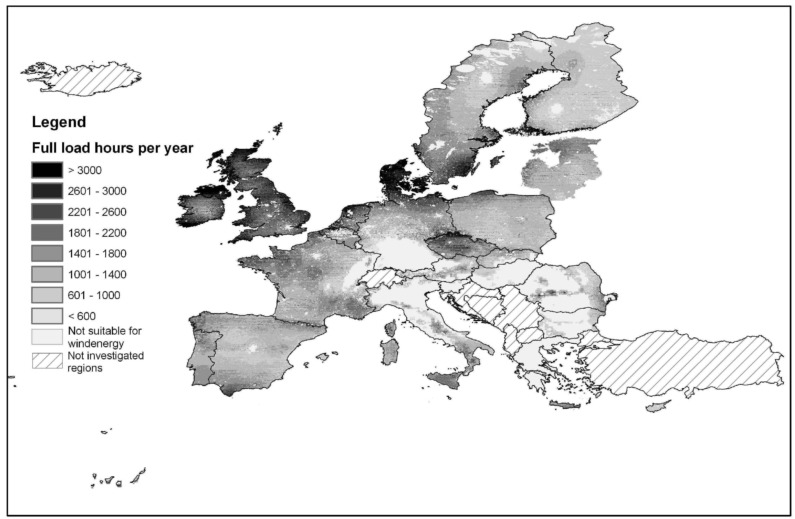
Figure 1 Annual full-load hours for wind onshore energy in the EU. Source: Own calculations
Figure 2 Electricity generation costs as a function of the full-load hours. Source: Own calculations

References
EurObserver (2008): Wind energy barometer, Systèmes solaires, n°183.
New, M.; Lister, D.; Hulme, M.; Makin, I. (2002): A high-resolution data set of surface climate over global land areas. In: Climate Research, 21.
WDPA Consortium (2006): WDPA Consortium World Database on Protected Areas web download (Copyright: UNEP-World Conservation Monitoring Centre – UNEP-WCMC).

