Long-term power plant investment planning in Baden-Wuerttemberg using a GIS-based nodal pricing approach

[Dipl.-Wi.-Ing. Anke Esser, Institute for Industrial Production, +49 (0) 721 608 4501, anke.esser@wiwi.uni-karlsruhe.de]
[Dr. rer. pol. Dominik Möst, Institute for Industrial Production, +49 (0) 721 608 4689, dominik.moest@wiwi.uni-karlsruhe.de]
[Prof. Dr. rer. nat. Otto Rentz, Institute for Industrial Production, +49 (0) 721 608 4460, otto.rentz@wiwi.uni-karlsruhe.de]

Overview

Due to the promotion of the use of renewable energy sources (RES) as well as of combined heat and power technologies, the number of small and medium size power plants which are installed in the German electricity supply system is increasing. However, due to the regionally differing availabilities of RES, the geographical distribution of existing units is very inhomogeneous. Therefore, regional aspects should be considered in the modeling of the German electricity supply system. In this context, transmission capacities become important. In the case of grid congestion, the regional marginal cost of electricity supply provide a basis for decisions regarding a regionally optimal power plant expansion. The objective of this work is to develop a modeling approach for the analysis of the long-term evolution of the German power supply system, taking into account its further decentralization. In this work the modeling approach will be applied to the region of Baden-Wuerttemberg.

Methods

Center stage in this analysis is the long-term expansion planning of the power supply system. Therefore, the following model requirements have to be fulfilled: The model shall include the techno-economical characteristics of the power supply system in a sufficiently detailed way. In addition, the location of existing infrastructure, regional potentials of RES (e.g. wind and biomass), regional characteristics of power demand, etc. shall be representable in the model. To meet those requirements a hybrid modeling approach has been developed, consisting of

the bottom-up material and power flow model PERSEUS-NET, and

a geodatabase containing all relevant georeferenced input data.

The optimizing energy model PERSEUS-NET is part of the energy and material flow model family PERSEUS (Program Package for Emission Reduction Strategies in Energy Use and Supply), extending it by a model of the German transmission network, and an optimal power flow model (DC). Using PERSEUS-NET the long-term development of supply systems can be analyzed. The main results of the energy system optimization with PERSEUS-NET are the optimal future power plant mix and the optimal topology of the power supply system. In the model, the main decision criteria for a geographically optimal power plant expansion are the locational marginal costs of electricity supply, which are determined by using a nodal (or locational marginal) pricing approach. Georeferenced data, such as regional potentials of RES or reasonable locations for power plant expansions options are integrated in PERSEUS-NET using georeferenced data stored in a newly-created geodatabase.

Results

In a first step the model is used to analyze the long-term development of the power supply system of the federal state of Baden-Wuerttemberg, which corresponds to the control area of the fourth largest energy supplier and system operator in Germany. In 2005 a total capacity of about 12,000 MW was installed within the region and the total power demand amounted to 245 TJ. The transmission net of the region (cp. Figure 1) is connected to the other German control areas via 10 inter-connectors. In addition, inter-connectors to the French, Swiss, and Austrian energy systems exist.

In Figure 1 the evolution of the regional distribution of the installed power production capacities and the power generation is shown. It can be seen that only few of the large production capacities are replaced. The power plant mix changes from a nuclear (32%) and coal (31%) based power supply system to a system in which mainly fossil fuel fired power plants are installed (gas: 42%, coal: 35%). Distributed resources, such as biomass, photovoltaics, or wind only play a minor role. Nevertheless, the share of RES in the power generation in Baden-Wuerrtemberg increases from 14% to 19% till 2030. This is in particular due to hydro-power generation. The low generation from other RES is on the one hand due to the very low potentials of RES in Baden-Wuerttemberg, and on the other hand explicable by their very high generation costs. Regarding the distribution of the power exchanges with other regions, the power imports from the rest of Germany (+26.5 TWh), Switzerland (+ 1.7 TWh) and Austria (+ 1.1 TWh) increase significantly till 2030.
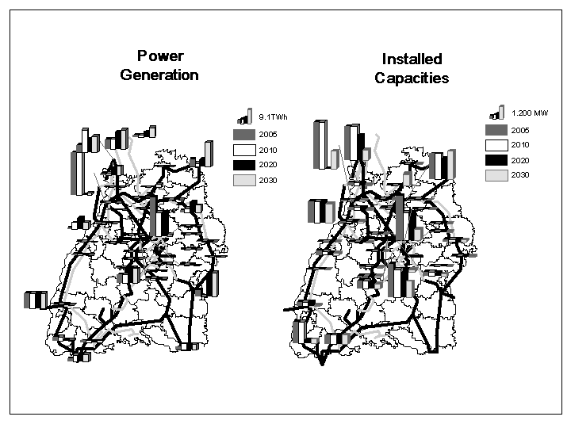
Figure 1: The regional development of the power supply in Baden-Wuerttemberg

Conclusions

With the application of the developed modeling approach to the region of Baden-Wuerttemberg it can be shown that an optimizing energy system model using a GIS-based nodal pricing approach is most suitable for an in-depth investigation of the long-term development of the power supply system. In the future, the model will be extended to entire Germany, where distributed generation is expected to play a more vital role in the evolution of the energy system than in Baden-Wuerttemberg.

