Modeling and Analysis of Energy Production Systems for Environmentally Conscious Supply Chain Management
Ahu SOYLU, London Business School, London, UK
Metin TÜRKAY, Koç University, Istanbul, Turkey

Overview
Energy is a fundamental entity of modern life that is required by industrial and service organizations as well as individual customers. In industrial settings, most facilities are clustered in a certain geographical area known as industrial complexes. Since these industrial facilities are located in geographical proximity, process integration and collaboration among them is feasible. Industrial facilities require energy primarily in two forms: steam and electricity. Electricity production in cogeneration systems are known to be the most efficient thermal energy producing systems. The energy production systems emit environmentally harmful substances by fossil fuel consumption during energy generation. With the demanding environmental regulations, the energy production systems must find new solutions continuously to decrease emissions while satisfying the energy demand.
A typical energy production system consists of storage tanks to inventory raw materials, boilers that convert fuel into steam at high pressures, turbines that expand higher pressure steam to lower pressure steam and convert the mechanical energy released during this expansion in the electricity and mixing equipment for mixing compatible materials originating from different sources in the system. Energy systems utilize fuel, air and other materials to generate electricity and steam. Companies can collaborate by exchanging steam. There is an investment cost for such inter-company material exchanges, i.e. pipeline construction. The energy production systems that collaborate in order to improve their financial and environmental performance can exchange steam while satisfying the demand for steam and electricity. If an energy production system produces excess electricity, it can sell this to utility company that serves the region. When enough electricity cannot be produced or if it is profitable, electricity can be purchased from the utility company.
The impact of Green House Gas (GHG) emissions on global warming can be measured in units of metric tons of carbon dioxide (CO₂) equivalent units. The Kyoto protocol puts emission decrease targets from the year 1990 emission levels of countries to achieve and the governments put individual decrease targets on companies. In CO₂ trading markets companies can exchange their CO₂ release permits to achieve these reduction limits.
Methods
It is worthwhile to know, with a cost benefit approach, how much it costs for the companies to conduct a pre-specified decrease in greenhouse gas emissions. This value can be useful to determine the amount of CO₂ that they can trade or emit. In order to assess that, the multi-objective nature of the energy systems is modeled.
The multi objective optimization is a decision support tool under the existence of more than one objective. In this study, the energy production systems, which face the conflict of emission reduction and cost minimization, are modeled as a Mixed-Integer Programming Problem with multiple objectives as a decision support tool in the CO₂ trading markets. By constructing efficient frontiers of the companies using realistic models, the CO₂ monetary value can be assessed. To our knowledge, that kind of a study incorporating detailed process models is new in the literature.
The multi-objective model has two conflicting objectives; minimization of total cost of production and minimization of total GHGas emissions, containing infinitely many efficient solutions. The efficient frontier of a multi-objective optimization problem is the collection of efficient points for the model. The set of points on the efficient frontier can be constructed by repeated optimization. Efficient frontier is helpful in the sense that, the decision maker can see the financial effect of reduction in GHG limits. By using efficient frontier, it is possible to assess CO₂ monetary value, i.e. cost of unit reduction in GHG emissions.
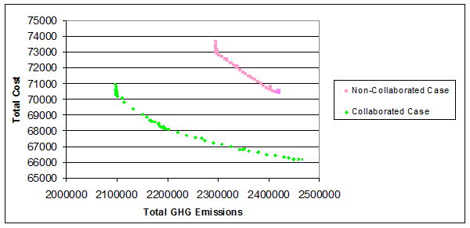
Figure 1. The Efficient Frontier of the Companies Operating under Collaborated Case
The graph explicitly shows the benefits of collaboration both in terms of financial and environmental criteria. In addition to that, if the companies are willing to decrease their GHG emissions, in order to perform the same amount of decrease, they should spend more in non-collaborated case. This is because the efficient frontier of the non-collaborated case is steeper than that of the collaborated case. Also, notice that it becomes more expensive to attain the same amount of reduction as the emission limits decreases.
Conclusions
In this study the best compromise solutions on the efficient frontier are calculated for different norm values that can be used as suggestions for decision makers. The synergy of collaboration is verified by comparison of efficient frontiers. This synergy is reflected both on economical and financial criteria. The effective use of efficient frontier in CO₂ trading is proposed. To our knowledge, solution of the energy production systems by multi-objective optimization and suggestion of using the results as a decision tool in CO₂ trading markets is not studied in the literature.

