ELECTRICITY STORAGE and Flexibility Requirements on the road to decarbonization in european electricity

Clemens Gerbaulet, TU Berlin and DIW Berlin, cfg@wip.tu-berlin.de

Casimir Lorenz, TU Berlin and DIW Berlin, cl@wip.tu-berlin.de

Overview
On the path to decarbonizing the European electricity sector the electricity generation portfolio is undergoing a significant transformation to a largely renewable and emissions free system. It is likely that the ambitious climate targets (80-95% reduction of green-house gas emissions by 2050) can only be reached when a significant share of electricity production comes from renewables such as wind and solar power, as nuclear power and CCTS technologies might not provide safe and/or feasible options of electricity supply (Kemfert et al., 2015).
While there is little dissent what the future electricity generation technologies might be, the implications of a decarbonized energy system with a possibly increased fluctuation of renewable infeed as well as a varying electricity demand are still discussed. The need of flexibility options regarding the storage of renewable energy, as well as demand flexibility increase is to be determined. Furthermore, the total level of electricity demand strongly depends on interdependencies of other sectors. This also leads to variations in the temporal structure of the electricity demand and in turn influences the required generation portfolio and the demand for flexibility.

Method
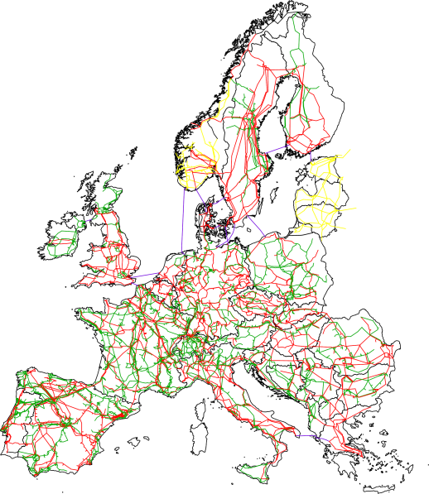
In this paper we focus on the development of flexibility options in Europe using a detailed representation of multiple storage technologies as well as demand flexibility options in an electricity sector model for Europe. Furthermore we take into account the total level of electricity demand, which depends on many influencing factors. We build upon the electricity sector model DynELMOD (Gerbaulet et al., 2014) that models the expansion of generation capacity as well as grid expansion need for all European countries in steps of five to ten years starting in 2015 until 2050. Given a set of boundary conditions such as yearly CO₂ emission budgets, technological parameters and technological availability and cost assumptions the model determines the cost-minimal generation portfolio, cross-border transmission expansion as well as the underlying generation and storage dispatch with an hourly resolution. The model is a linear problem and solved in an integrated way, taking into account all time steps as well as the underlying model hours of generation dispatch in a single optimization step. We extend the model with a detailed storage technology representation including multiple storage technologies with varying technical characteristics and associated cost parameters representing short-, mid-, and long-term storage options such as Li-Ion batteries and pumped hydro storage. In a second step, options for increasing the demand flexibility are evaluated and implemented.
Figure 1: DynELMOD Model Area
Source: Egerer et al., 2014
The approach allows us to draw conclusions about the sensitivities regarding the type, timing, volume, and location of storage capacity and demand side flexibility expansion needs with respect to boundary conditions such as variations in installation cost as well as changes on the demand side. The country-sharp results and sensitivities of storage investments for all time periods in conjunction with generation investment give a good indication of the inherent interdependencies between renewable expansion and the kinds of flexibility characteristics needed to complement the fluctuation of renewable feed-in. The hourly resolution of the model allows to take into account a large portion of the renewables’ fluctuation and electricity demand variations.
Due to the interconnected nature of the electricity system, cross-country interactions are heavily influenced by the available electricity transfer capacities. We implement the cross-border interaction by flow-based market coupling instead of net transfer capacities. This allows us to model the market coupling implementation likely to be adopted by an increasing number of transmission system operators in the future. In 2016, flow-based market coupling is active in the region CWE (Central Western Europe). This market-coupling implementation builds on a detailed DC load-flow representation of the underlying electricity grid (Egerer et al., 2014; Leuthold et al., 2012).

Results
Preliminary results show that about 250 to 300 GW storage capacities are built by the model. The amount and regional distribution of the storage capacities is less sensitive to variations in investment cost than expected. The main driver of flexibility need is the level of renewable deployment in conjunction with availability of interconnection between countries as increased interconnection can provide a cost-effective alternative to installation of short- and mid-term flexibility options such as batteries or pumped hydro storage.
Furthermore, a scenario analysis with varying capacities of nuclear power for electricity generation does not significantly change the total system costs. A further scenario analysis with varying demand shows a high sensitivity to the deployment of storages.
Figure 2: Exemplary electricity generation development in Europe in a scenario with an almost complete decarbonisation.
Source: Own depiction.

Conclusions
The paper at hand implements several generation and demand flexibility options into a bottom-up generation expansion model that is applied to the European electricity sector in the timeframe 2015 to 2050. We analyse the need for electricity storage and other flexibility options in the context of the decarbonization of the electricity sector and the transformation to a mostly renewables based system. We find that the need for flexibility options is smaller than originally anticipated, as fluctuations can be evened out between country especially when transmission capacity is available. The spatial distribution and demand for storage is less influenced by the investment cost but mostly by the amount of wind and solar power as well as interconnection capacity between countries.

References
Egerer, J., Gerbaulet, C., Ihlenburg, R., Kunz, F., Reinhard, B., von Hirschhausen, C., Weber, A., Weibezahn, J., 2014. Electricity Sector Data for Policy-Relevant Modeling: Data Documentation and Applications to the German and European Electricity Markets (DIW Data Documentation No. 72). Berlin.
Gerbaulet, C., Kunz, F., Lorenz, C., von Hirschhausen, C., Reinhard, B., 2014. Cost-minimal investments into conventional generation capacities under a Europe-wide renewables policy. IEEE, pp. 1–7. doi:10.1109/EEM.2014.6861297
Kemfert, C., von Hirschhausen, C., Reitz, F., Gerbaulet, C., Lorenz, C., 2015. European climate targets achievable without nuclear power. DIW Economic Bulletin 5, 619–625.
Leuthold, F., Weigt, H., Hirschhausen, C. von, 2012. A Large-Scale Spatial Optimization Model of the European Electricity Market. Networks and Spatial Economics 12, 75–107. doi:10.1007/s11067-010-9148-1

