Measuring Long-Run Demand Elasticities for Petroleum Products in OPEC

Carol A. Dahl, Professor, Mineral and Energy Economics Program,Colorado School of Mines, Golden Colorado, USA and Visiting Professor, Department of Economics, College of Business Administration, King Saud University, Riyadh, Saudi Arabia, 1-303-273-3921, cdahl@mines.edu
Afaf A Abaalkhail, Lecturer, Department of Economics, College of Business Administration, King Saud University, Riyadh, Saudi Arabia, 966-548-450-011, aabaalkhail@ksu.edu.sa

[Format: single space, 10 point font, Times New Roman]

Overview
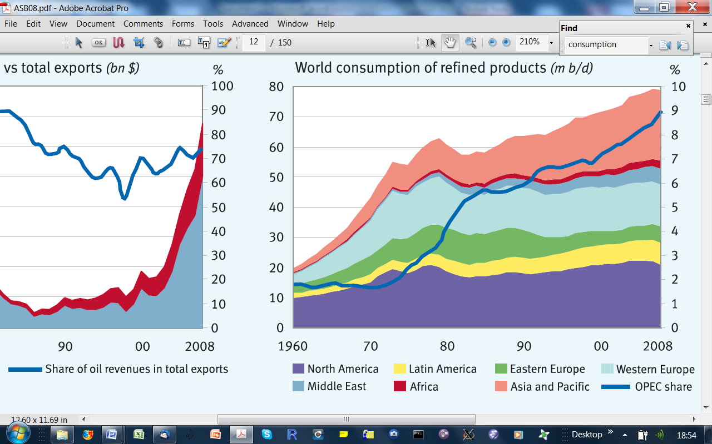
OPEC has seen rapid increases in oil product consumption with annual increases in excess of 3% for the past two decades. They represent about 20% of the increase in world oil consumption over this period. This relative increase can be seen in the figure to the right with the only region that has seen faster growth in this period is the Asia Pacific region. Low oil product prices, increasing population, rapidly developing economies, and increasing wealth have all likely contributed to this increasing thirst for oil among the oil producers. Whether this increase will continue is of great interest to the oil producing countries. High growth means that oil exports may have to be diverted to the domestic market with important implications for government revenues. Consumering countries are keenly interested as well. High OPEC growth may raise product prices with important ramifications for consuming countries economies. It is also of global interest to a world trying to constrain carbon emissions. Our paper will help provide information on the long term growth of oil products in OPEC countries by econometrically estimating long run price and income elasticities of demand for individual OPEC countries for four oil products, gasoline, diesel fuel, kerosene, and heavy fuel oil. We chose these four products because they constitute a high share of the oil barrel consumed in these countries and because we have price and quantity series available for each of them.
Source: OPEC Annual Statistical Bulletin, 2008

Methods
Historically various methods have been used to try to separate short and long run. In demand survey work, Dahl (1993) notes that often cross sections pick up more elastic price and income elasticities than time series. Thus, consumers may have made long term adjustments to the prices and incomes in their cross sections, while time series may show how consumers make shorter run adjustments to changing price and income across time. This same pattern seems to hold in more recent demand analysis. Dahl (2011). Since the long run typically requires adjustments to the capital stock and short run adjustments relate more closely to changes in the use of the capital stock, more sophisticated analysis models capital stock purchases and capital stock use. However, we do not have capital stock data to allow such modelling. Although data exist on vehicle stocks, Al Dossary (2008) did not find very satisfactory results with vehicle stock inclusion for these countries leading us to question the accuracy of the data. The most common way around this absence of accurate capital stock values has been to estimate models with lagged values of variables. The most often used has been the lagged endogenous model which allows estimation of both long and short run elasticities which we represent as follows.
Where O = the consumption of the oil product, P is its price, and Y is some measure of economic activity such as GDP. Population and other variables can, of course, be incorporated into this basic formulation. Although parsimonious, such a model puts rather strong restrictions on lag structure and forces the same lag structure on all variables in the system.Thus lags in response to income are the same as lags in response to price. Lagged exogenous variables have also been used, which allow for less restrtictive lag structures that can vary for different exogenous variable. However, more recently with developments in time series, studies have started to check whether time series variables in the models are stationary or not and whether non-stationary variables in the model are co-integrated. Under this newer interpretation, if levels of variables move together and are co-integrated, then this co-integrating relationship is interpreted as measuring a long relationship or long run elasticities. The error from this long-run relationship can be substituted into an error correction model that is estimated to measure the short run adjustments across time as follows:
Under this Engel and Granger (1987) two step procedure, the long-run is estimated from a model without lags, whereas the long run in other models is estimated from lags. In survey work, Dahl (1993) and Dahl (2011) found that these two approaches tend to find different long run elasticities in many different energy demand studies, particularly for the income elasticity. Estimated long-run income elasticity for the lagged endogenous model may be 50% higher than from the Engel – Granger two step. In our paper, we will systematically compare the estimates from the varying approaches – cross – section versus time series, lagged endogenous versus two step error correction versus one-step error correction. We will determine whether the various approaches give similar estimates for the long run price and income elasticities, if not we will try to quantify any systematic differences in results, and determine which methodology gives preferred results using out of sample forecasting.

Results

The results will include our best guess of the long run price and income elasticities of demand for four oil products for individual OPEC countries. Since GDP in these countries tends to be quite volatile with cycles in the oil market, some attention will be paid to the best measure of economic activity. Dahl (forthcoming) developed price and income elasticities for gasoline and diesel fuel from surveying existing studies and also found patterns about how price and income elasticities evolved as countries developed and prices changed. We will check whether these patterns hold for OPEC countries for gasoline and diesel price and income elasticities as well as look for patterns and structural changes within the countries that may give us clues to future consumption patterns. Results will also be compared to the existing literature. Often oil prices have been used in estimating demand for these countries. We suspect that oil and product prices may be inversely related suggesting that such a practice may give very misleading price elasticities. We also hope to be able to comment on the robustness of the various modelling methodologies, whether they give similar results or not, and whether we can pick a preferred methodology or not.

Conclusions
Our conclusions will relate to the quantitative values of long run elasticities, our confidence in these values, and the methodologies we found most satisfactory in arriving at our conclusions. The work should have implications for evaluating existing studies and for modeling petroleum demand in other areas of the world.

References
Al Dossary, Nasser (2008) “Global Demand for Road Transport Fuels“ Ph.D. Thesis, Mineral Economics Program, Colorado School of Mines, Golden, Colorado.

Dahl, Carol A. (1993) “A Survey of Energy Demand Elasticities in Support of the Development of the NEMS.” Prepared for the US Department of Energy Under Contract De-Ap01-93EI23499.

Dahl, Carol A. (2011) "Survey of Global Energy Demand Elasticities" Work in progress.

Dahl, Carol A. (forthcoming) “Measuring Global Gasoline and Diesel Price and Income Elasticities,” Energy Policy, Special Issue on Transport Modelling.

Engle, R. F. and Granger, C. W. J. (1987). "Co-integration and Error-correction: Representation, Estimation and Testing". Econometrica 55(2), 251–276. doi:10.2307/1913236

